# Practical No. 1

## Problem Statement

Design and develop agent-based model by

* Creating the agent population
* Defining the agent behavior
* Add a chart to visualize the model output.

[Use a case scenario like grocery store, telephone call center etc for the purpose].

## Solution

Close the Welcome page, and create a new model by selecting **File** *>* **New** *>* **Model** from AnyLogic's main menu. The **New Model** wizard will open.

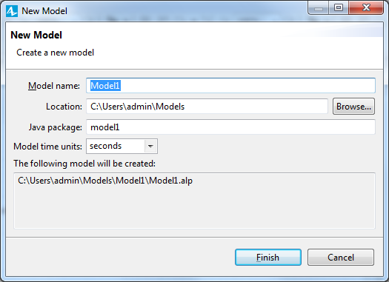

In the **Model name** box, enter the new model's name: Market.

In the **Location** box, select the folder where you want to create the model. You can browse for a folder by clicking **Browse** or type the name of the folder you want to create in the **Location** box.

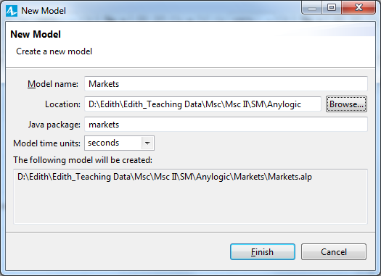

Select **Model time units** to be **days** andClick **Finish**.

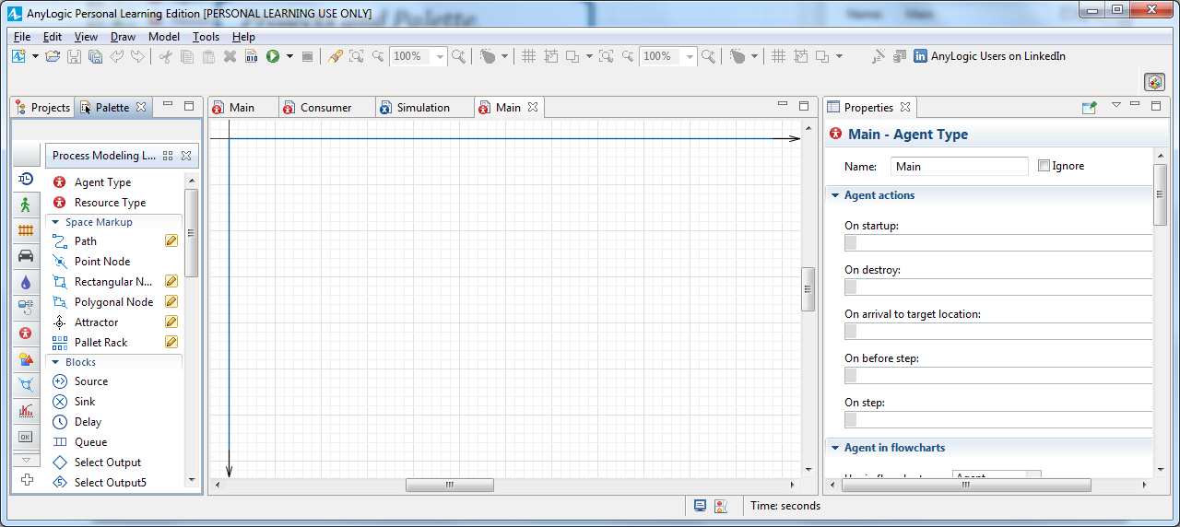

Our model has one agent type, Main.

To add consumers, we’ll need to create an agent type to represent consumers, and then create an agent population made up of instances of this consumer agent type. In AnyLogic 7, you can use the helpful **New agent** wizard to create agents.

We want to add a new model element, but we first need to switch to the **Palette** view by clicking the **Palette** tab.

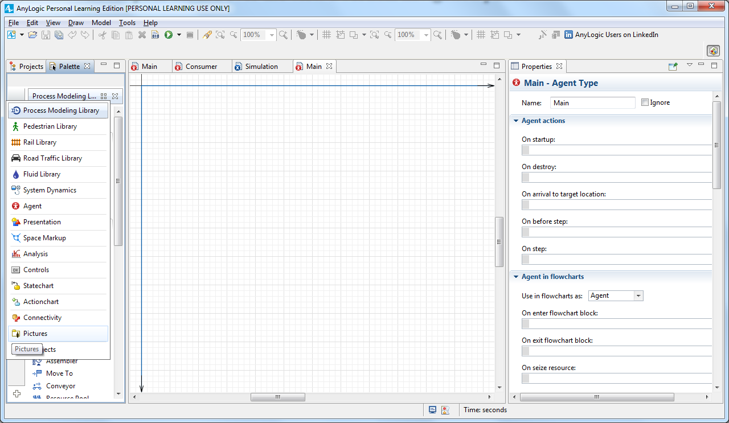

Drag the **Agent** from the **Agent** palette on to the Main diagram, and the **New agent** wizard will open.

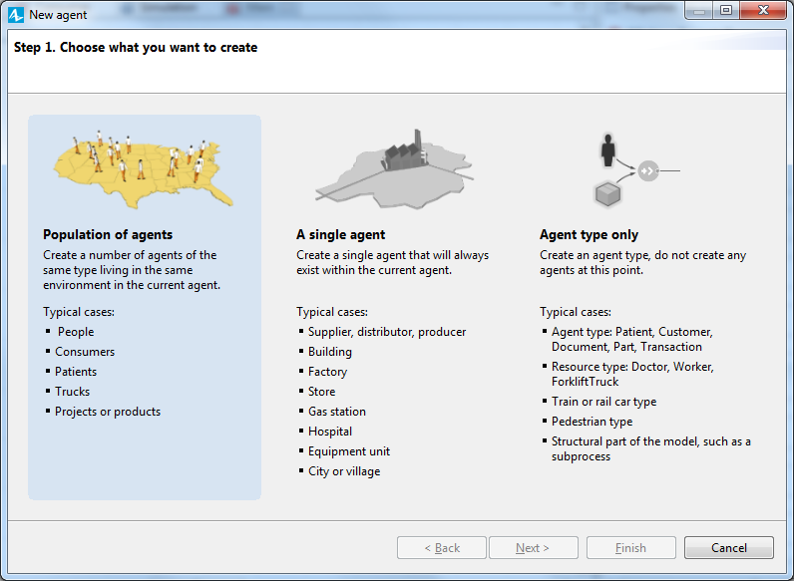

On the **Step 1. Choose what you want to create** page, select the option that best meets your needs. Since we want to create multiple agents of the same type, select **Population of agents** and click **Next**.

On the **Step 2. Creating new agent type** page, in **Agent type name** box, type **Consumer**. The information in the **Agent population name** box will automatically change to consumers.

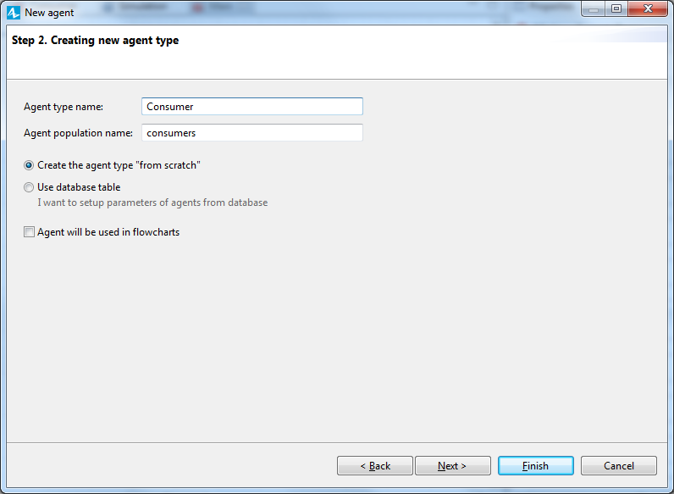

Click **Next**.

On the **Agent animation** page, choose the agent’s animation shape. Since we’re creating a simple model that uses 2D animation, choose **2D**, select the **General** list’s first item: **Person**, and click **Next**.

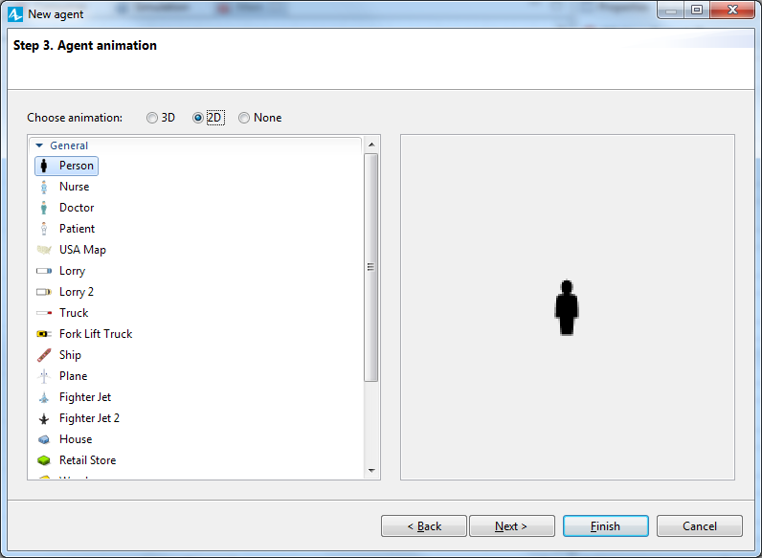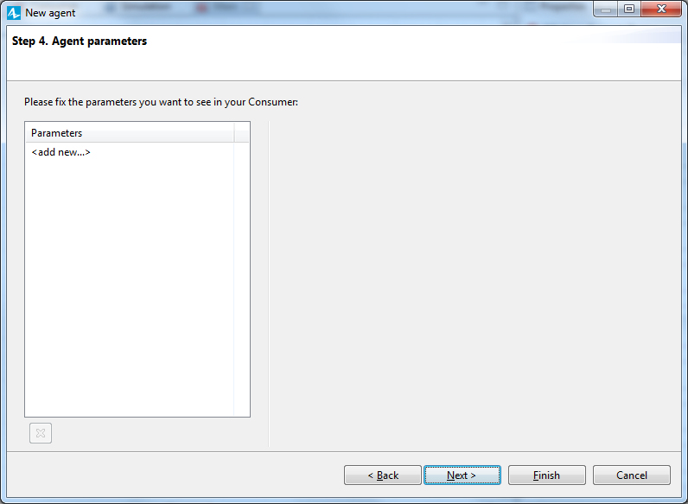

On the **Agent Parameters** page, define the agent’s parameters or characteristics. Since our model only considers advertising-related product purchases, we’ll add a parameter - **AdEffectiveness** - to define the percentage of potential users who become ready to buy the product during a given day.

On the left section, in the **Parameters** table, click **<add new…>** to create a parameter.

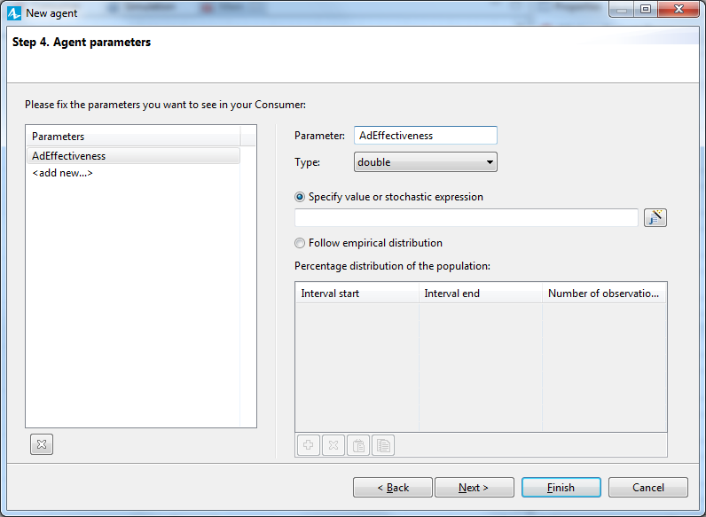

In the **Parameter** box, change the default parameter’s name to **AdEffectiveness**, and choose **double** as the parameter **Type**. We’ll assume an average of 1% of our model’s potential users will want to buy the product during a given day, so specify 0.01 as the parameter's value.

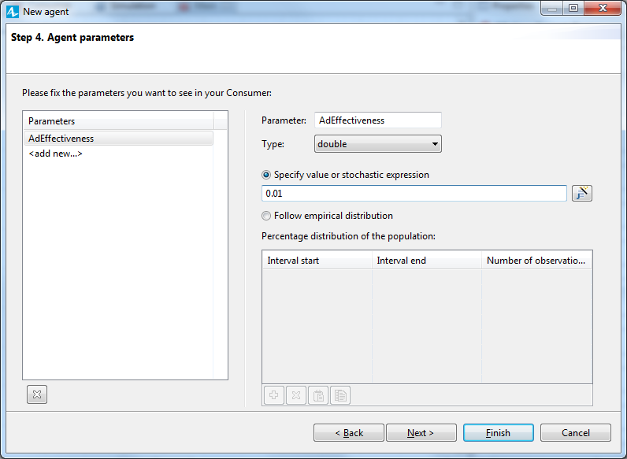

Click **Next.**

On the **Population size** page, type 5000 in the **Create population with agents** box to create 5000 instances of the Consumer type. Each instance in the population will model a specific agent-consumer.

While we’ve created our agent population, we won’t see 5,000 Person animation figures on Main diagram. Instead, AnyLogic will use the 5000 agents in the population we’ve called consumers to simulate the market when we run our model.

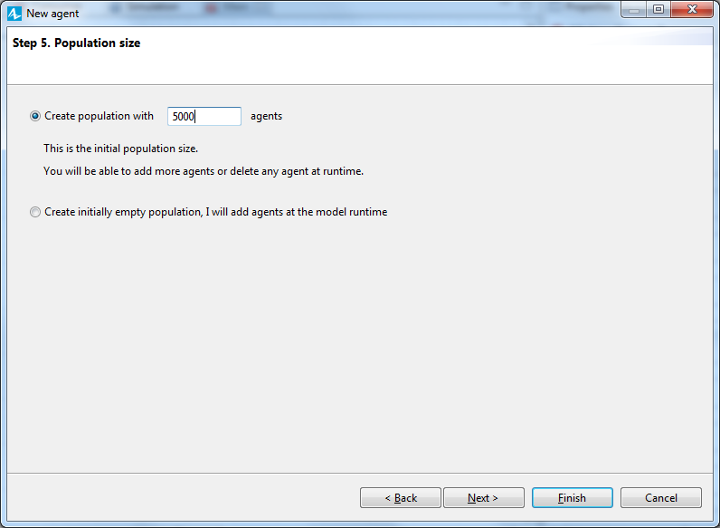

Click **Next**.

On the **Configure new environment** page, accept the default values for the environment’s space type (**Continuous**) and both its **Width** and **Height** values (500). AnyLogic will display the agents in a 500x500 pixel rectangle.

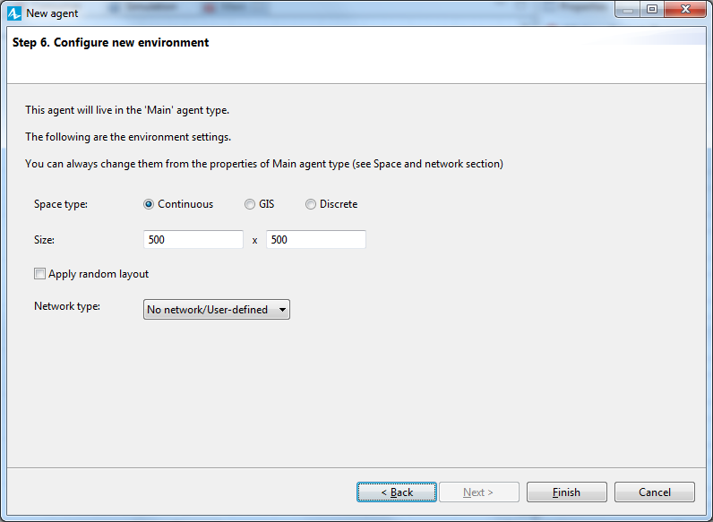

Select the **Apply random layout** box to randomly distribute the agents across the 500 X 500-pixel width and height we’ve defined. Since we don’t want to create an agent network, we’ll accept the default **No network/User-defined** network type.

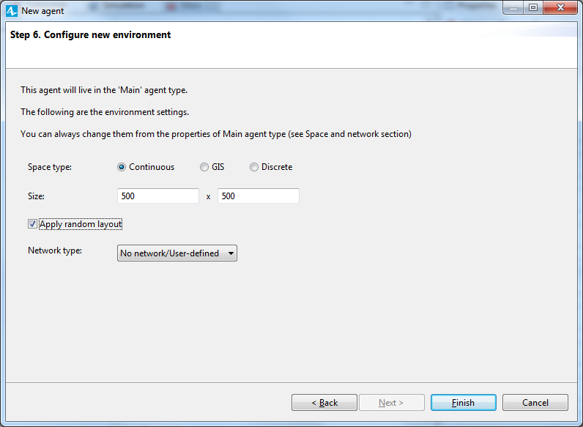

Click **Finish**.

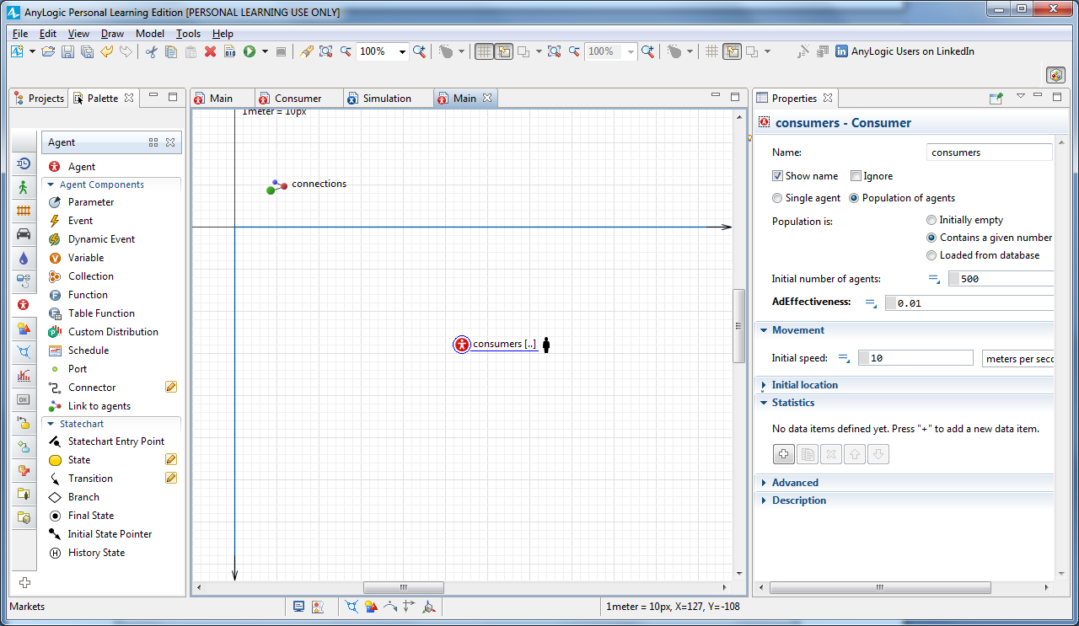

Let’s use the **Projects** view to see the new elements that the wizard created. Expand the model tree branches to see the internals.

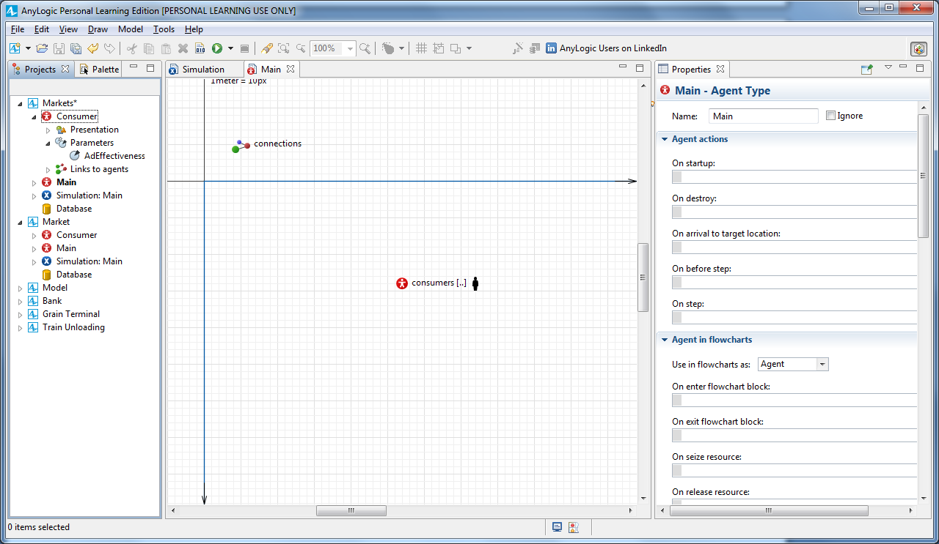

Our model now has two agent types: Main and Consumer.

* The Consumer agent type has the agent’s animation shape (person, in the **Presentation** branch) and the parameter AdEffectiveness.
* The Main agent type contains the agent population consumers (a set of 5000 agents of type Consumer).

Click **Main** in the **Projects** to open its properties in the **Properties** view (you’ll find **Properties** in the AnyLogic window’s right half).

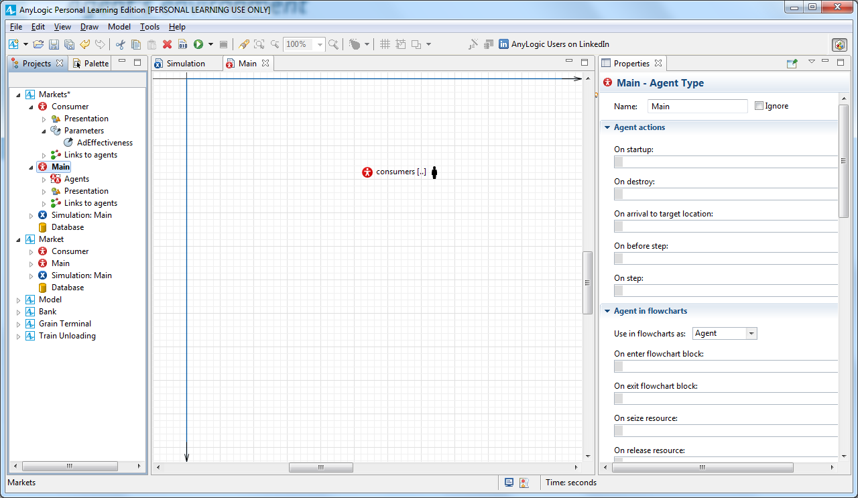

In the **Space and network** section of Main properties, you can adjust the environment settings for the consumers agent population.

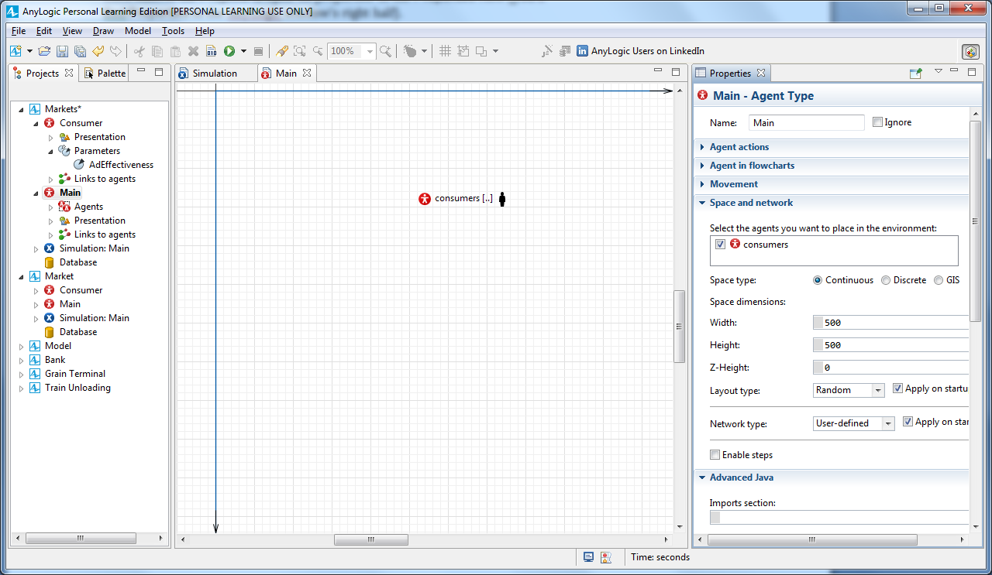

On Main diagram, select the agent population’s non-editable embedded animation shape, open the **Advanced** properties section, and select the **Draw agent with offset to this position** option.

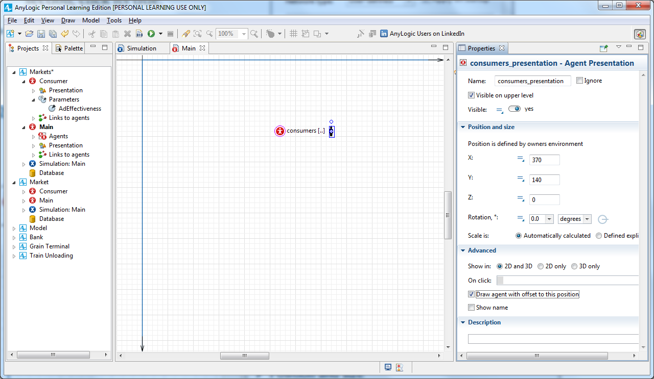

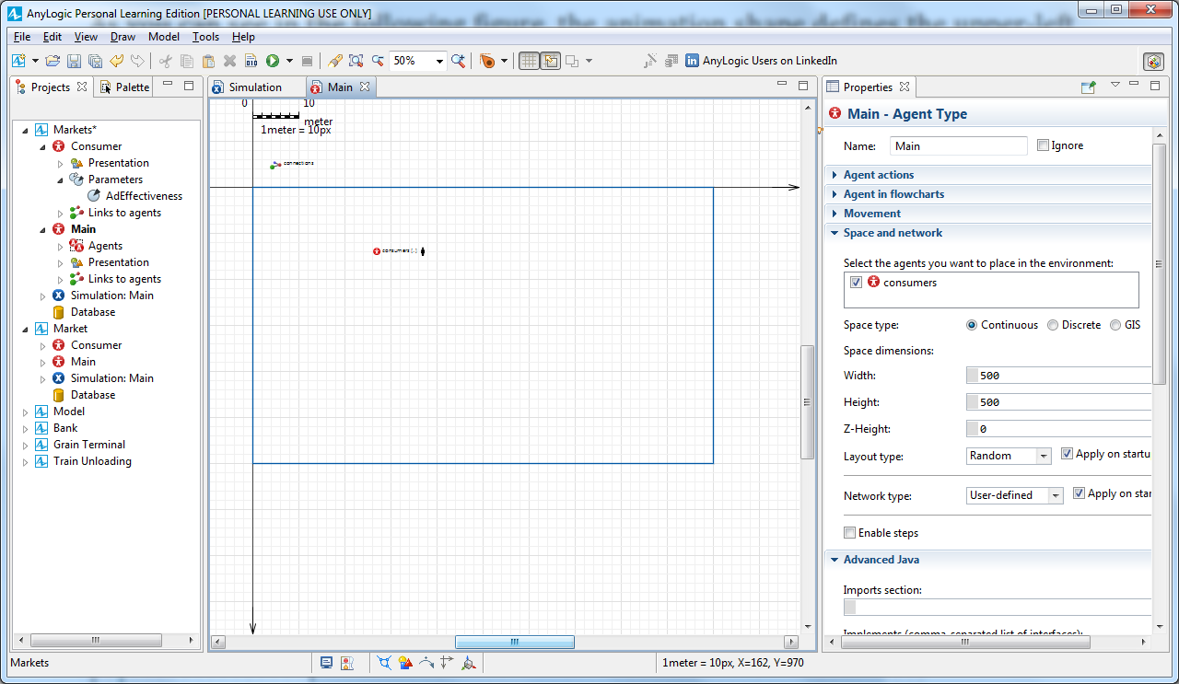

We’ve finished building this very simple model, and you can now run it and observe its behavior.

On the toolbar, click the **Build** button to build the model and check it for errors.

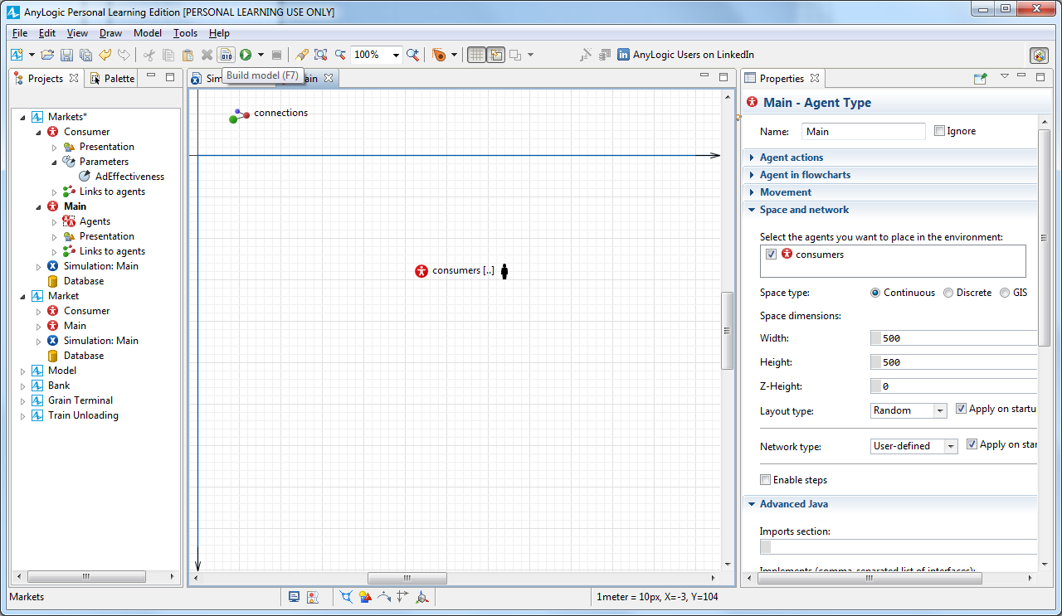

Locate the **Run** button, and click the small triangle to the right. Select the experiment you want to run. Choose **Markets / Simulation** from the list.

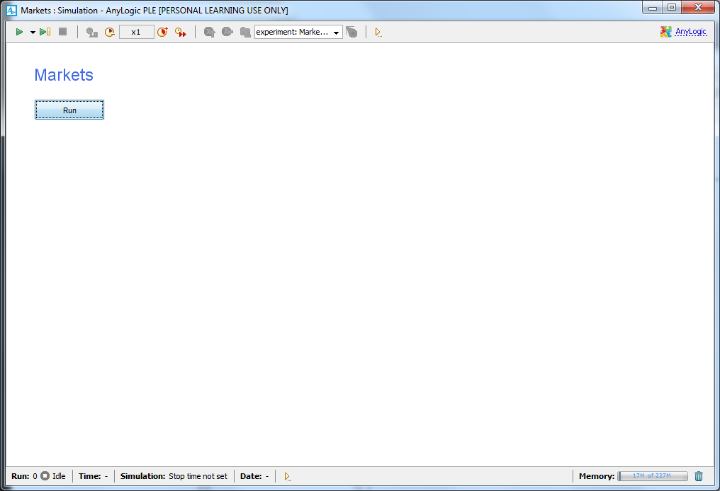

Click the **Run** button to run the model.

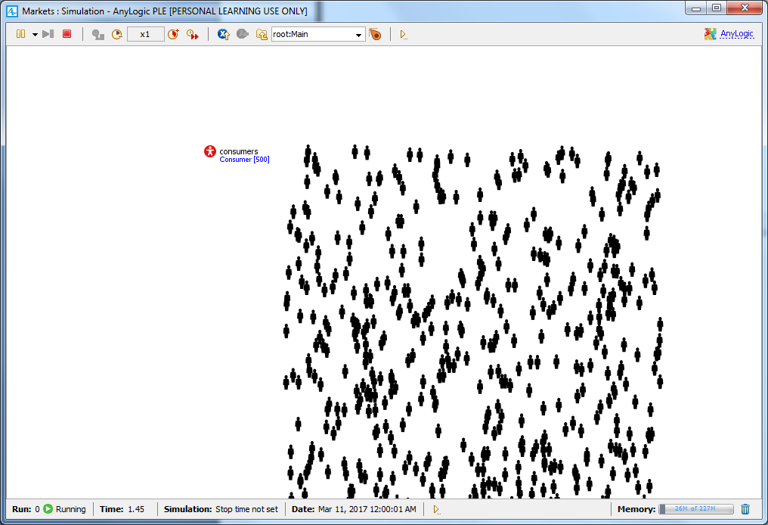

**Defining a consumer behavior**

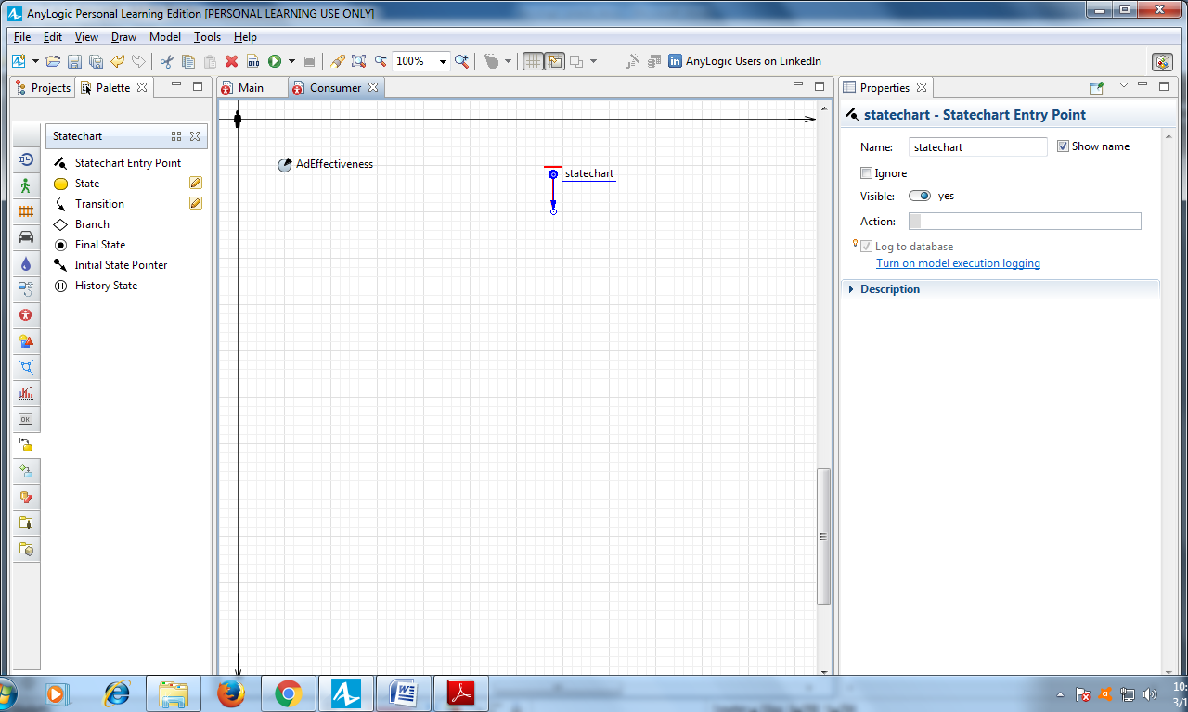

Drag the **State** from the **Statechart** palette on to the graphical diagram, and

connect it to the statechart entry point.

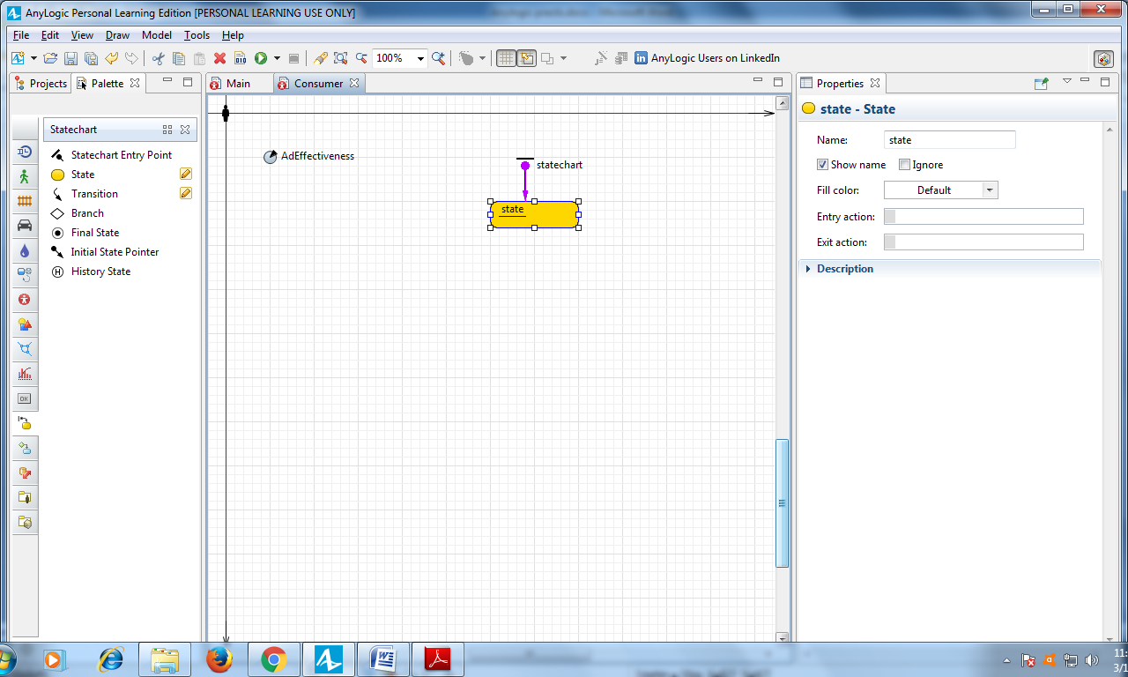

Select the state in the graphical editor, and modify its properties. Name the

state PotentialUser.

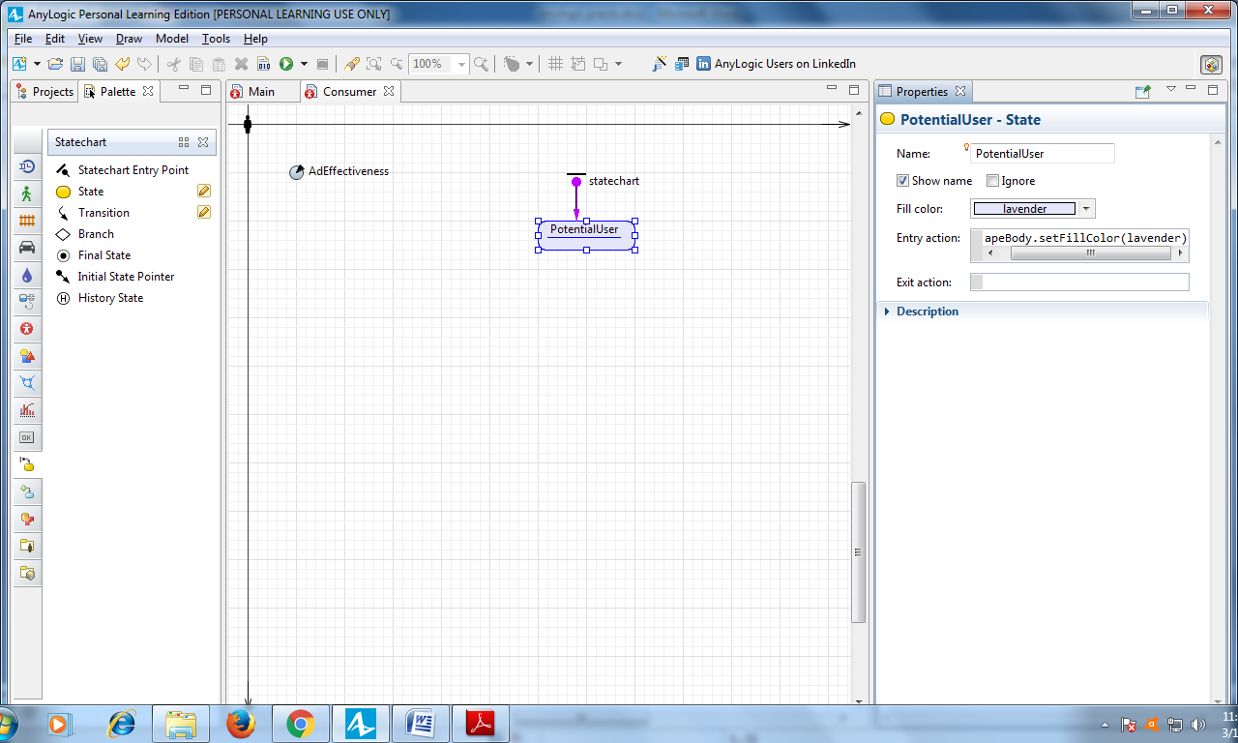

Use the **Fill color** control to change the state’s color to lavender.

Type the following Java code in the state’s **Entry action** field: shapeBody.setFillColor(lavender)

Add another state in the consumer's statechart:

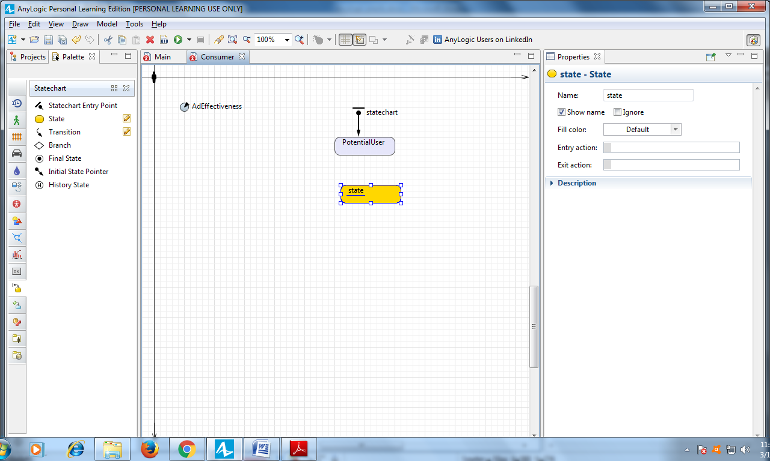

Modify the state's properties like you did earlier:

**Name**: User

**Fill color**: yellowGreen

**Entry action:** shapeBody.setFillColor(yellowGreen);

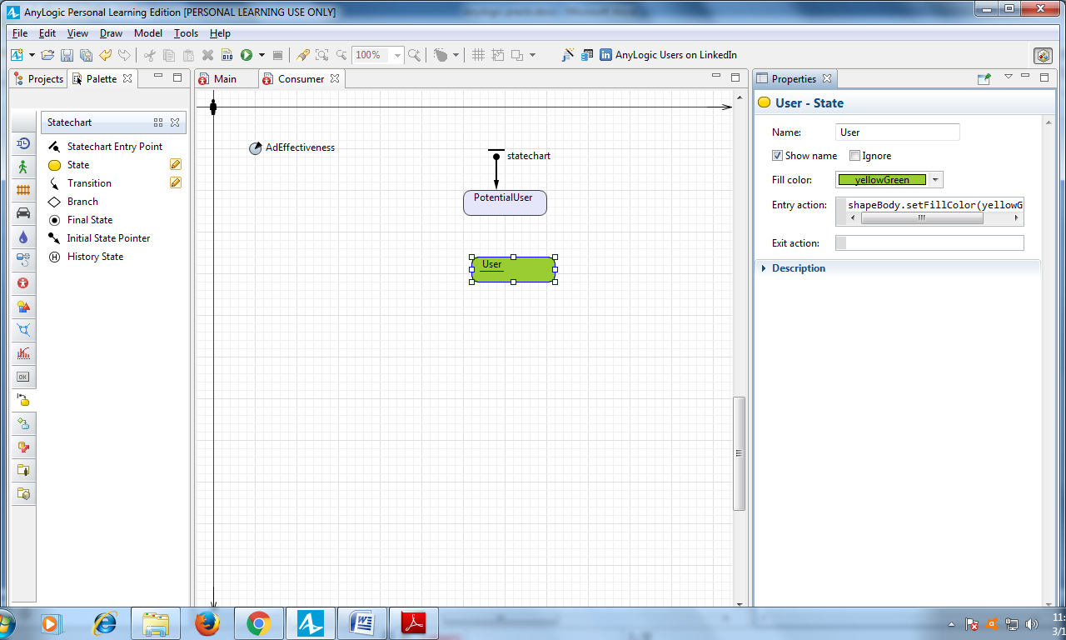

Draw a transition from PotentialUser to User state to model how persons purchase the product and become product users. To do so, double-click the **Statechart** palette’s **Transition** element (the element’s palette icon should change to), click **PotentialUser** state, and click **User.**

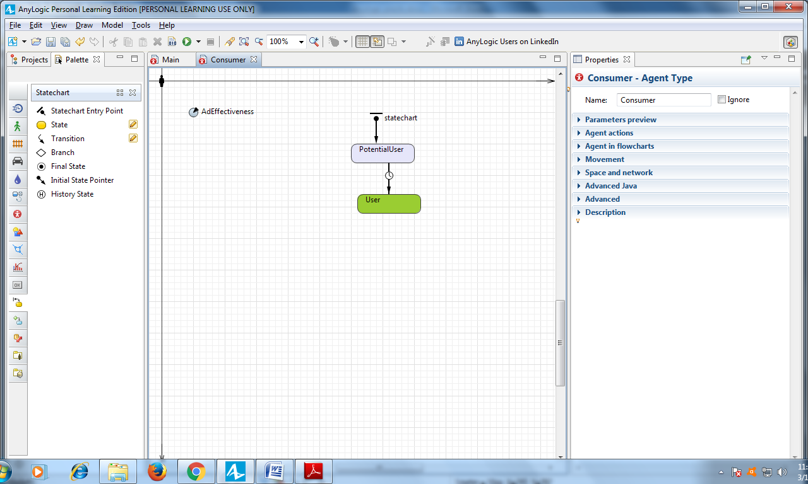

Name the transition Ad to represent “advertising”.

Select the **Show name** checkbox to display the transition’s name on the graphical diagram.

The transition from PotentialUser to User state will model how advertising leads the person to buy the product. In the **Triggered by** list, click **Rate**. In the **Rate** field, type AdEffectiveness, and then click **per day**.

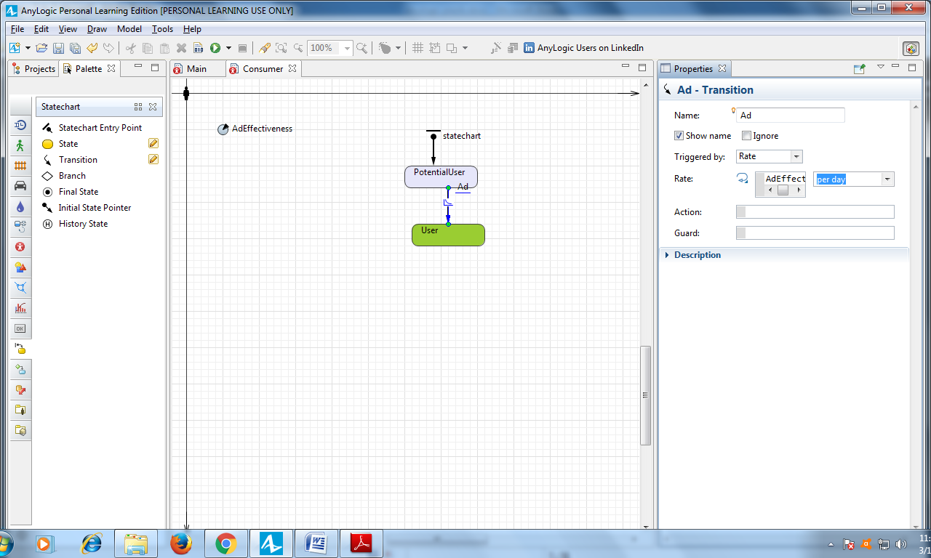

Now, let’s set up the model’s time units. To tune the model setting, switch from **Palette** to **Projects**, and then click the model item in the tree (the tree's top object, Market). In the **Properties** view, choose **days** as the **Model time units**.

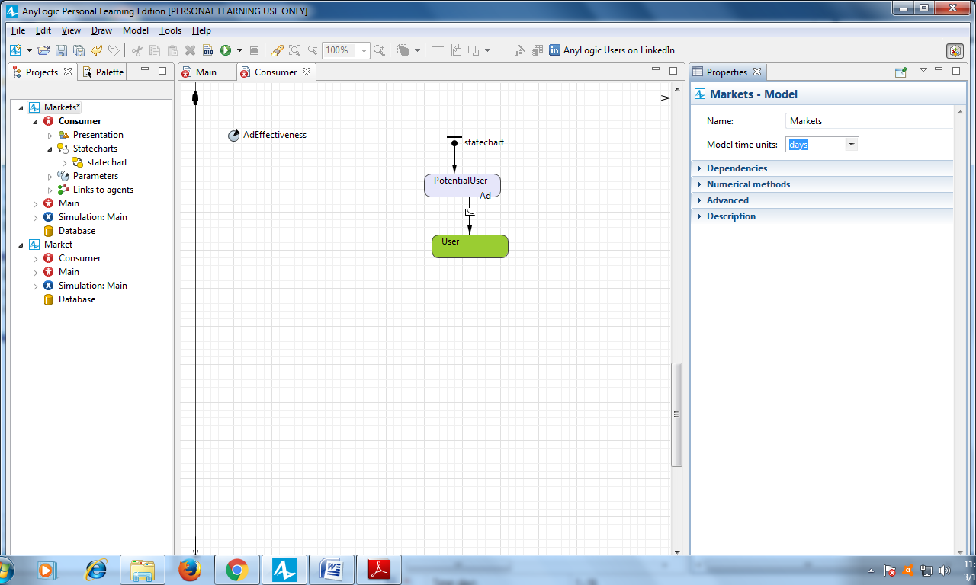

Run the model. The population should gradually turn green – a change that represents the effect of advertising - until every consumer buys the product.

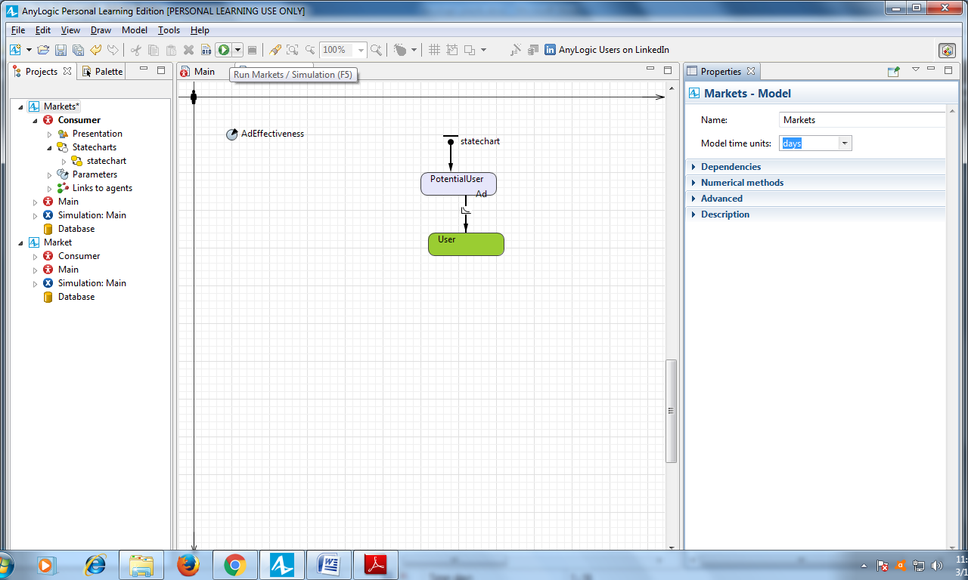

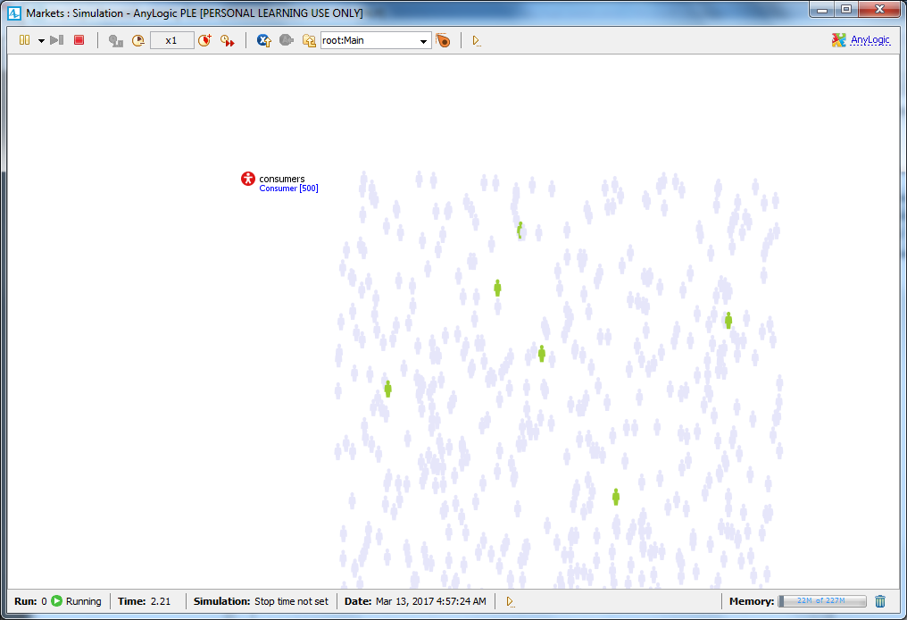

To adjust the model's execution speed, click the toolbar’s **Slow down** or **Speed up** buttons. If you increase the speed to 10x – you’ll see the speed at which the population turns green also increase.

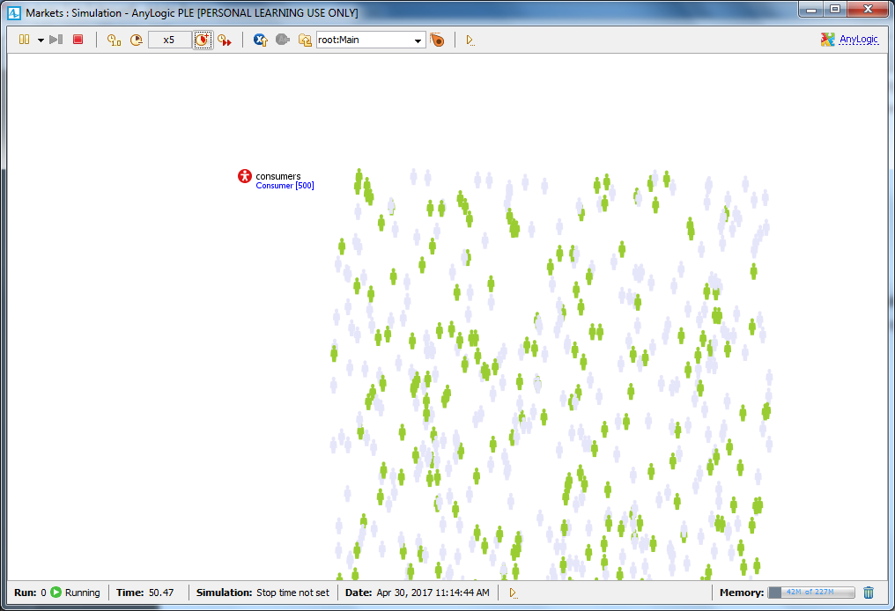

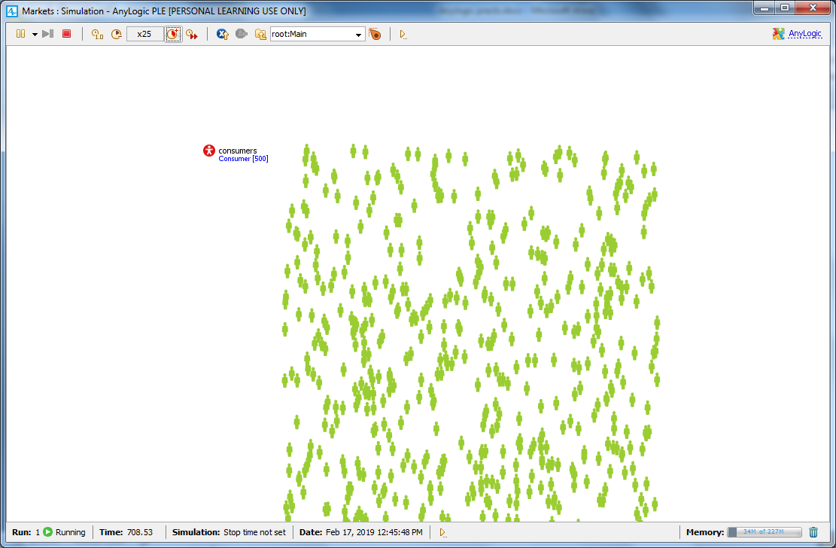

**Adding a chart to visualize the model Output**

First, define a function to count potential users. To add a new function that collects statistics for agents, open the diagram of the agent type Main, select the agent population consumers, and go to the **Statistics** properties section.

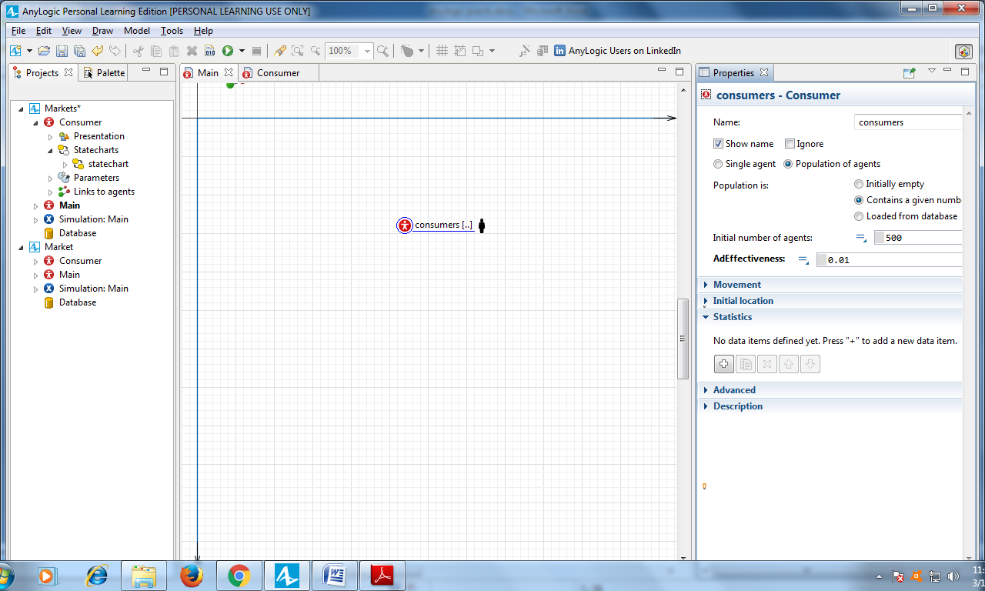

Define the function of type **Count** with the **Name** NPotential. The statistics of type **count** iterates through a given population – in our case, the number of agents – to count those that meet the selected condition.

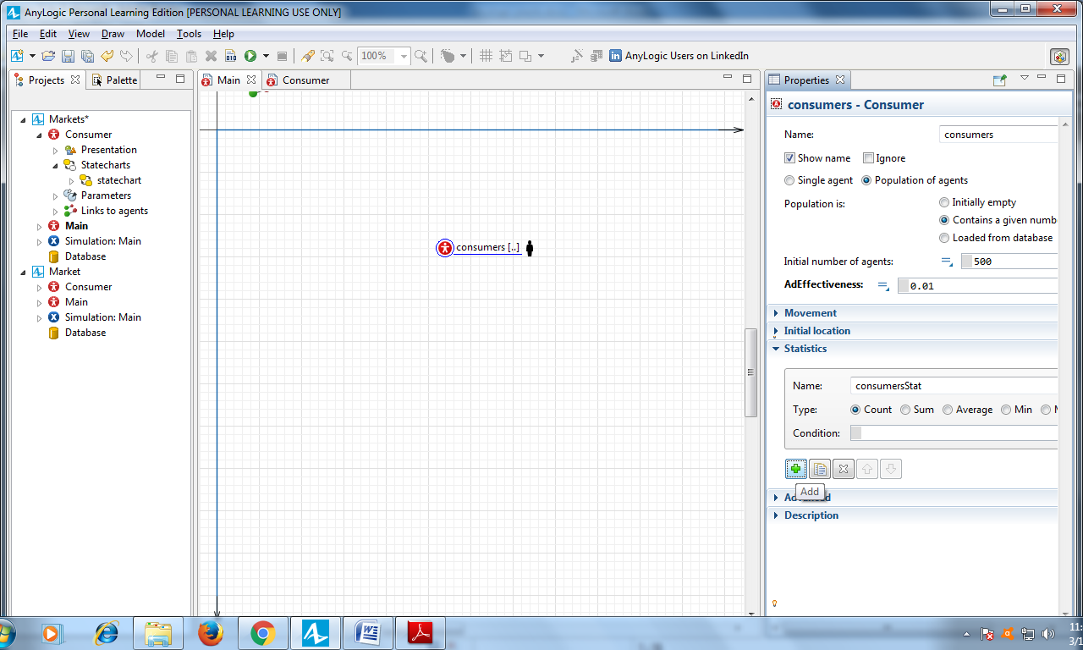

Enter item.inState(Consumer.PotentialUser) as the function **Condition**.

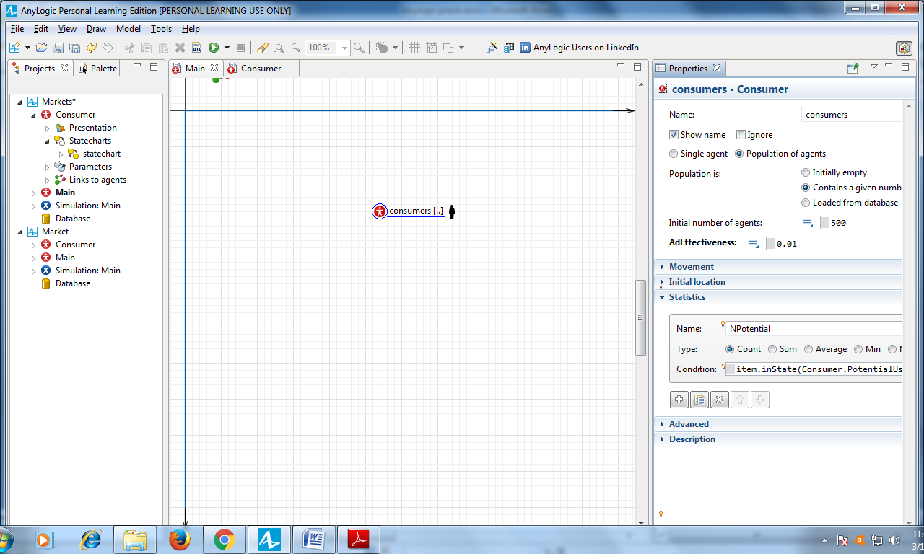

Define a second statistics function to calculate the number of product users.

Name it NUser and let it count the number of agents, conforming the **Condition** item.inState(Consumer.User). You can duplicate the other statistics function by clicking the **Duplicate** button and changing its **Name** and the C**ondition**.

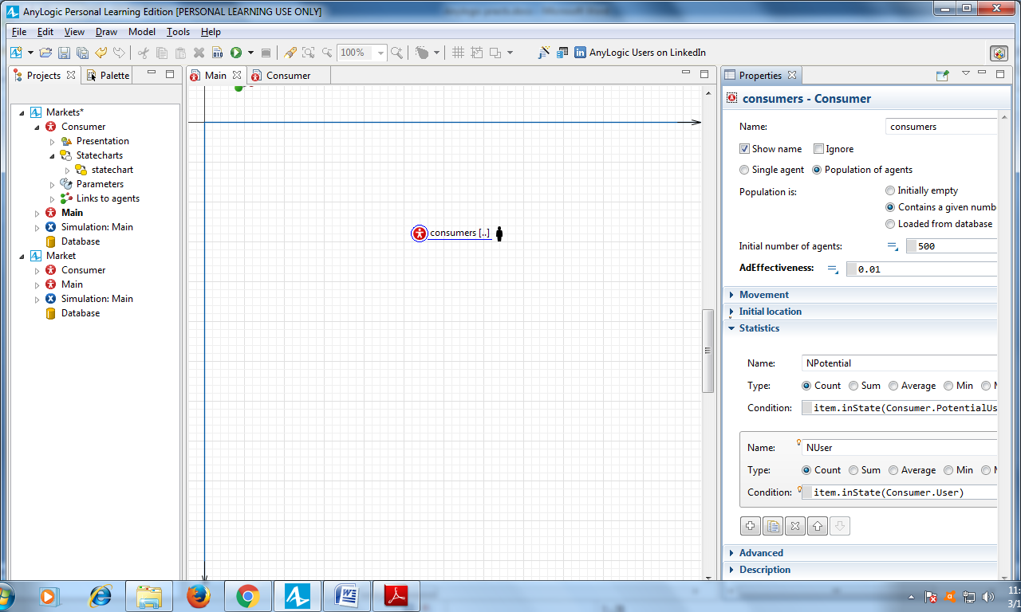

Now, let’s add a chart to show the statistics these functions collect and display the

adoption process dynamics.

Open the **Analysis** palette, and drag the **Time Stack Chart** from the **Analysis** palette on to the Main diagram to create a chart that will display the dynamics of users and potential users.

Increase the time stack chart as shown in the figure below:

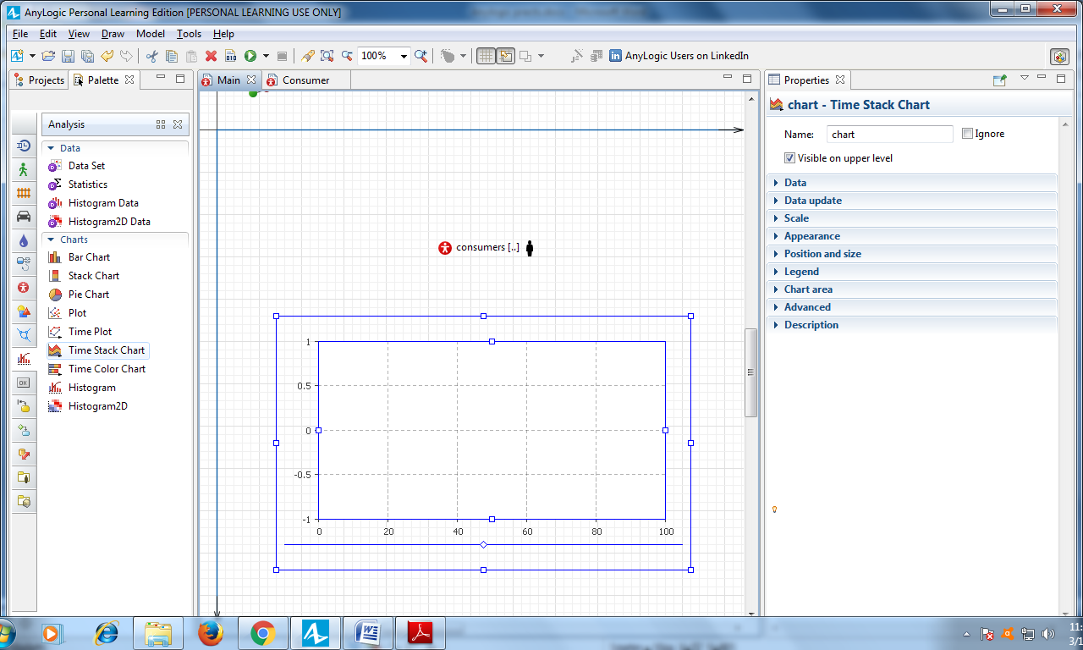

Add two data items for the chart to display. Here we’ll call our statistics functions NUser and NPotential we have defined for consumers population on the previous step.

Click **Add data item** to add the statistics you want to draw on the chart.

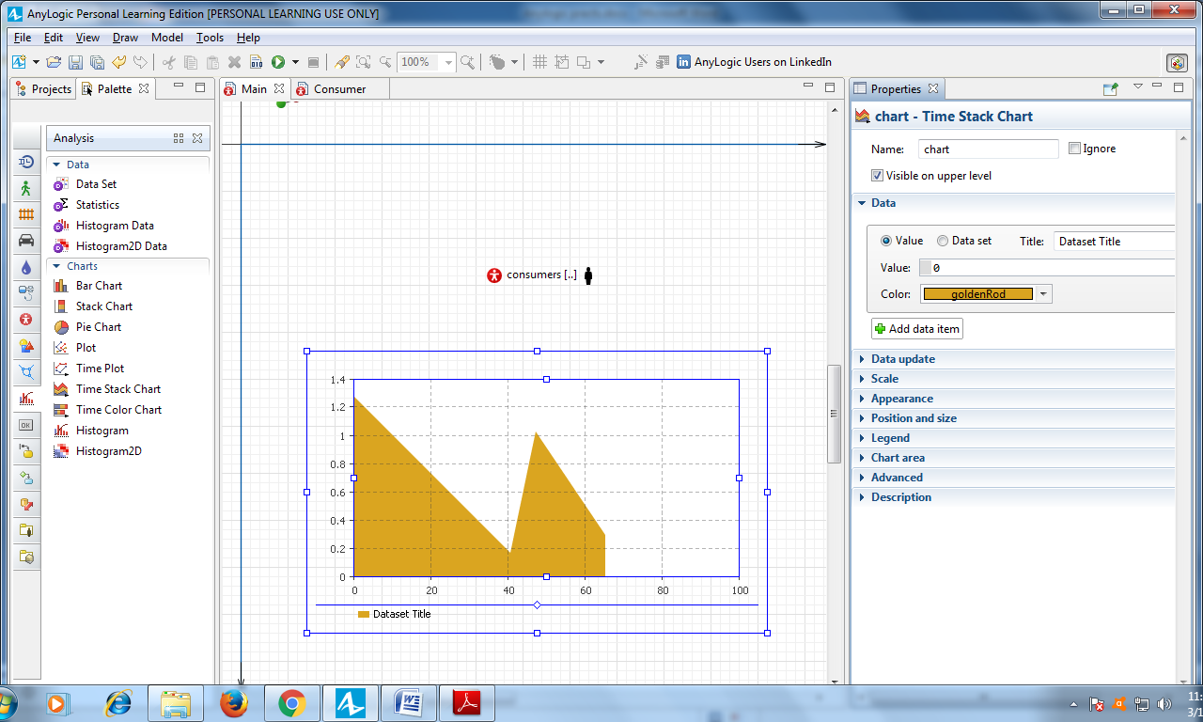

Modify the data item's properties:

• **Title**: Users – the data item's title.

• **Color**: yellowGreen

• **Value**: consumers.NUser()

Our agent population name is consumers, and NUser() is the statistics function that we defined for this population.

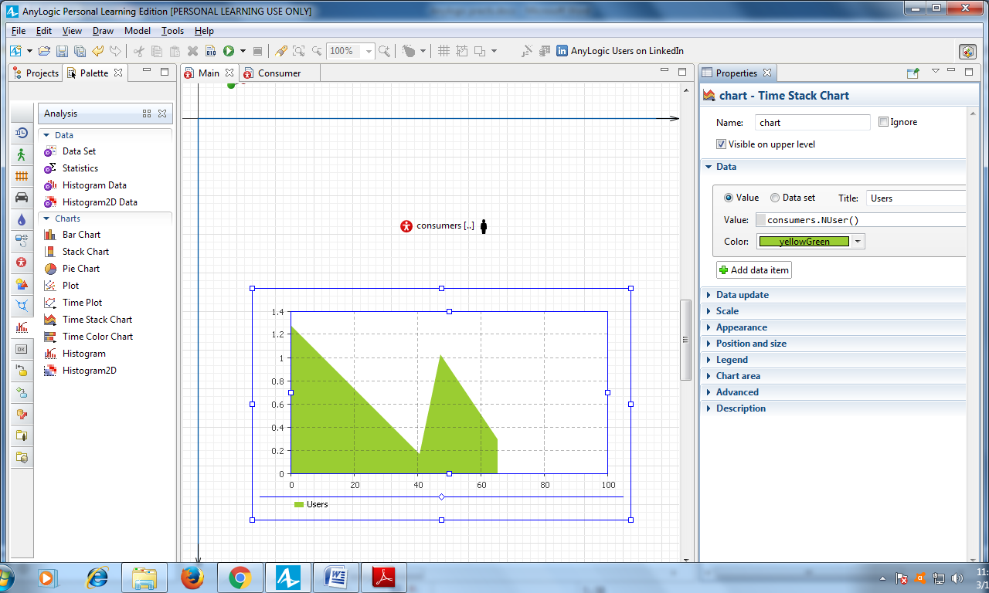

Add one more data item:

• **Title**: Potential users

**7**

AnyLogic 7 in Three Days **61**

• **Color**: lavender

• **Value**: consumers.NPotential()

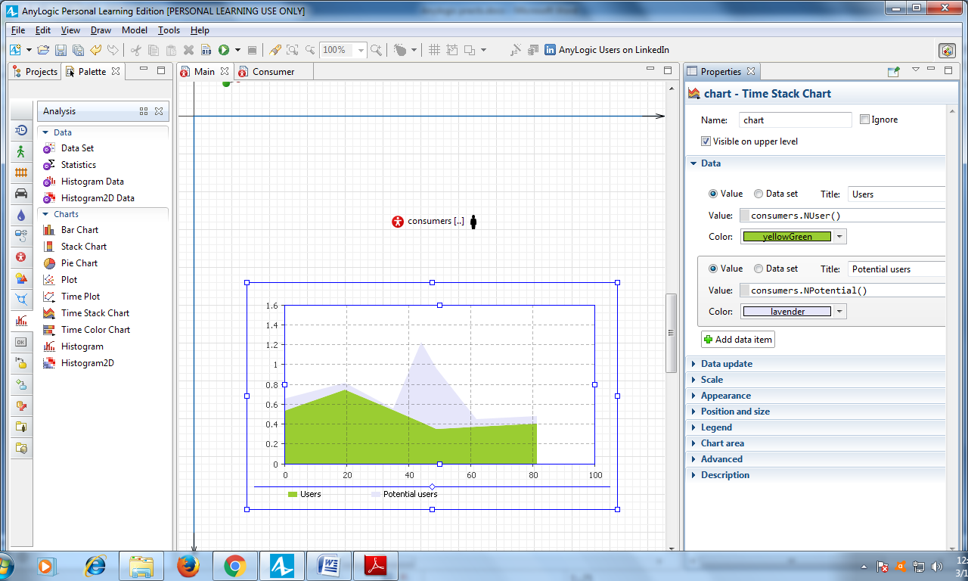

Go to the **Scale** section and set **Time window** equal to 1 year.

Since our chart will show statistics for consumers population and our model

has 5,000 consumers, set the chart’s **Vertical scale** to **Fixed**, and enter 5000 in

the **To:** box.

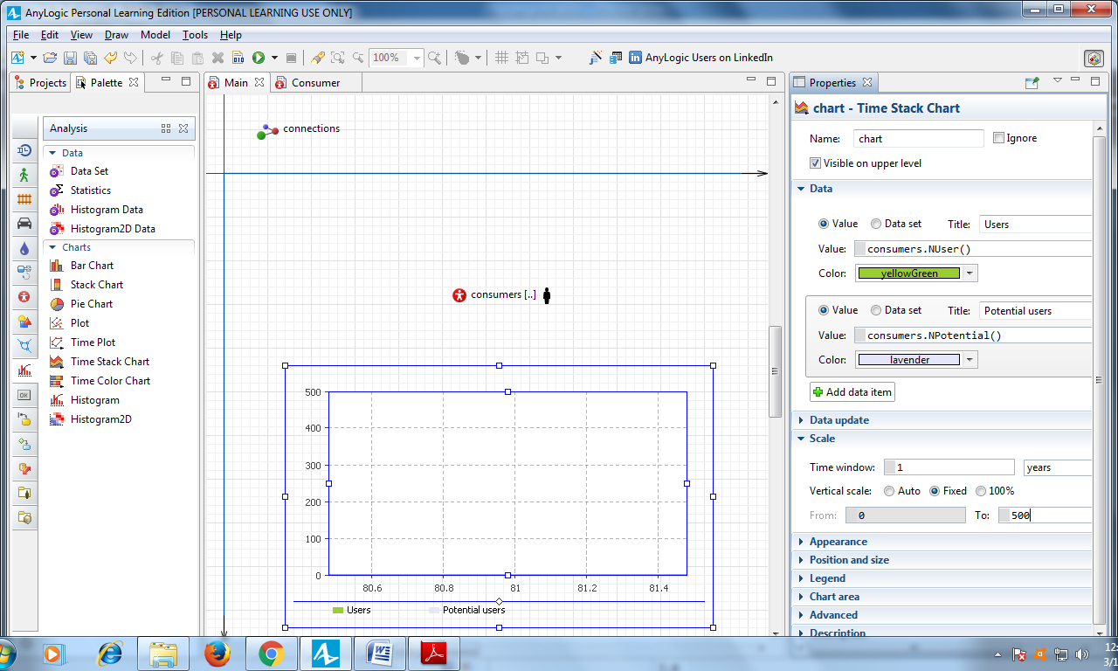

Now that we’ve set the time window, change the maximum number of data samples that the chart displays by navigating to the section **Data update** and setting **Display up to** 365 **latest samples**. Since we’ll add one data sample each day, 365 data samples is an ideal amount for a one year range.

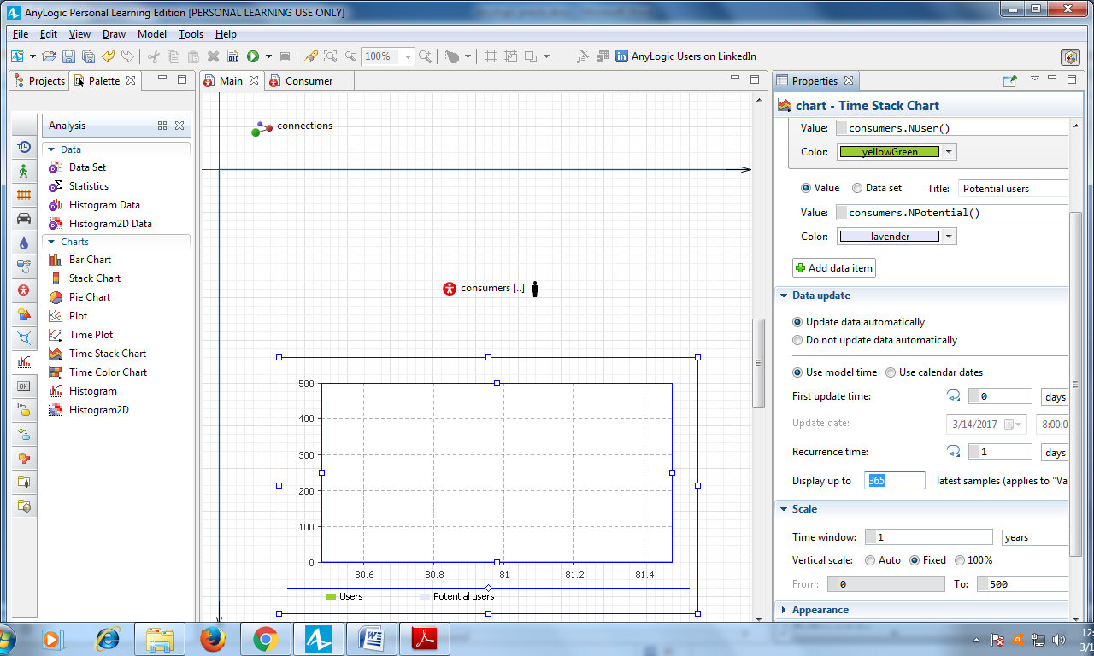

Go to the time stack chart's **Appearance** properties and set it to display **Model date (date only)** near the time axis.

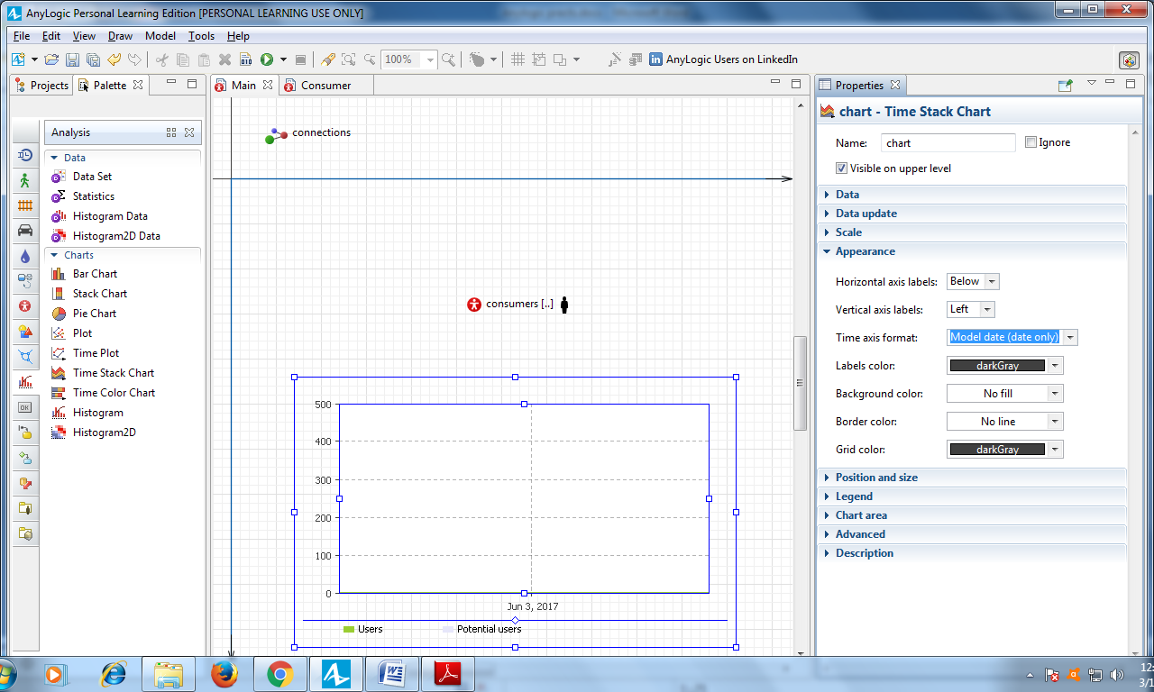

On the Main diagram, move the presentation of the consumers agent population to the right.

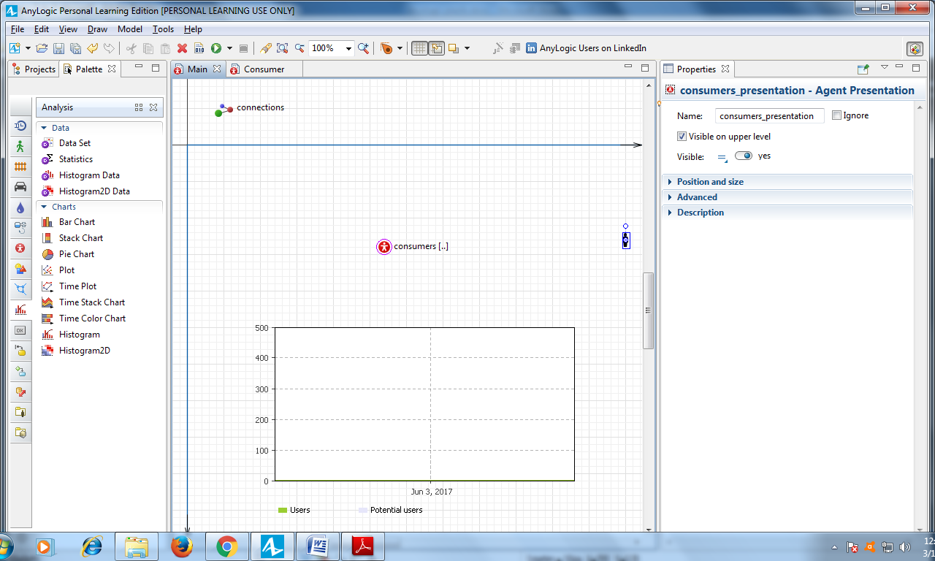

Run the model and use the time stack chart to review the process.

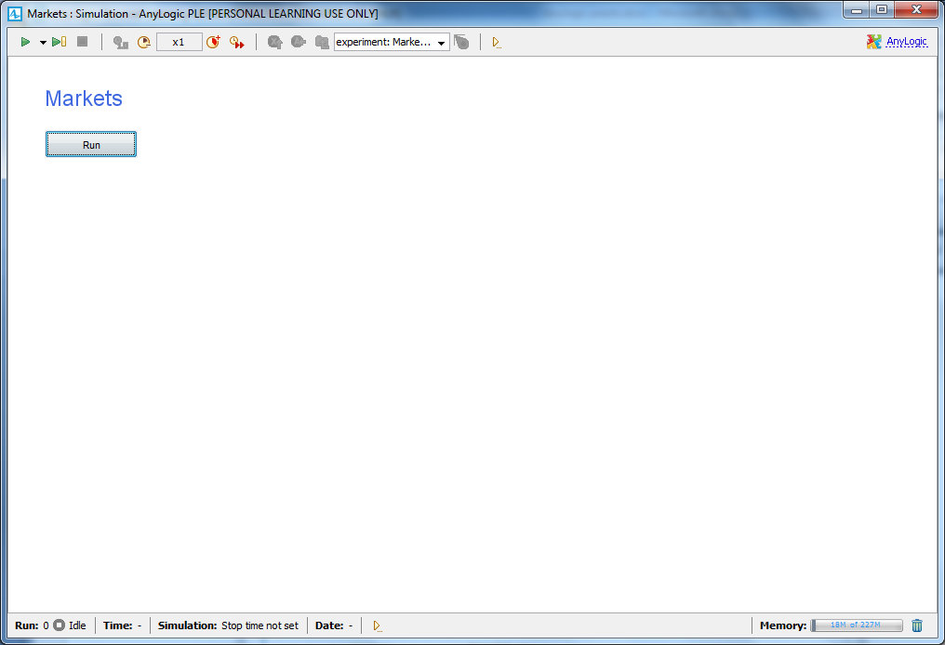

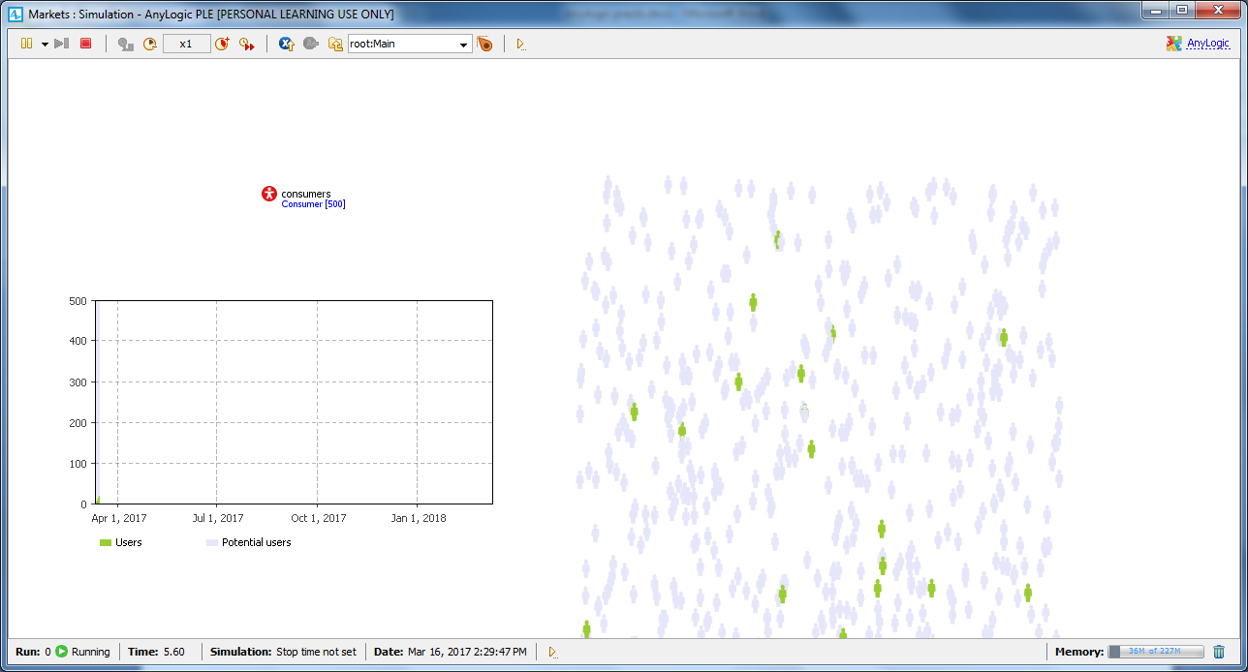

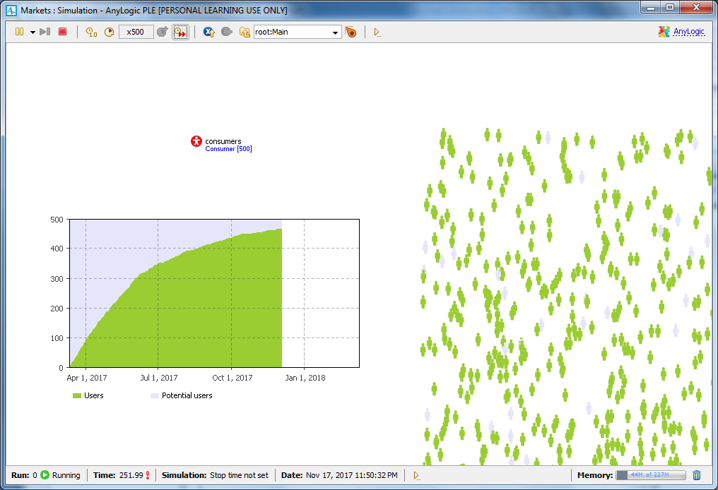

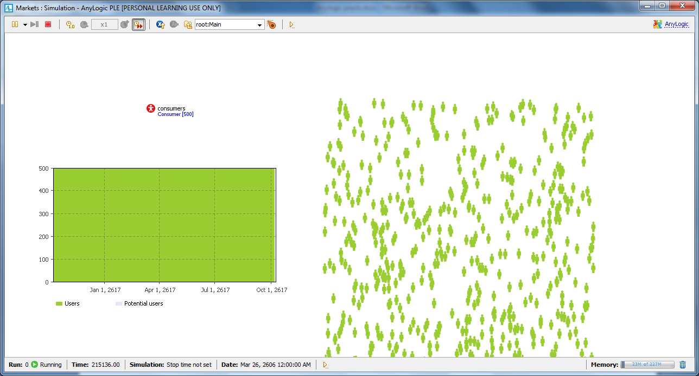

# Practical 2

## Problem statement

Design and develop agent-based model by

* Creating the agent population
* Defining the agent behavior
* Adding a chart to visualize the model output
* Adding word of mouth effect
* Considering product discards
* Considering delivery time

## Solution

**Adding word of mouth effect**

In the **Projects** tree, open Consumer diagram by double-clicking Consumer.

Add a parameter to define a consumer's average daily contacts. Drag the **Parameter** from the **Agent** palette on to the diagram. Name the parameter **ContactRate**.

The rate is 1 contact per day, so type 1 as the parameter’s **Default value**.

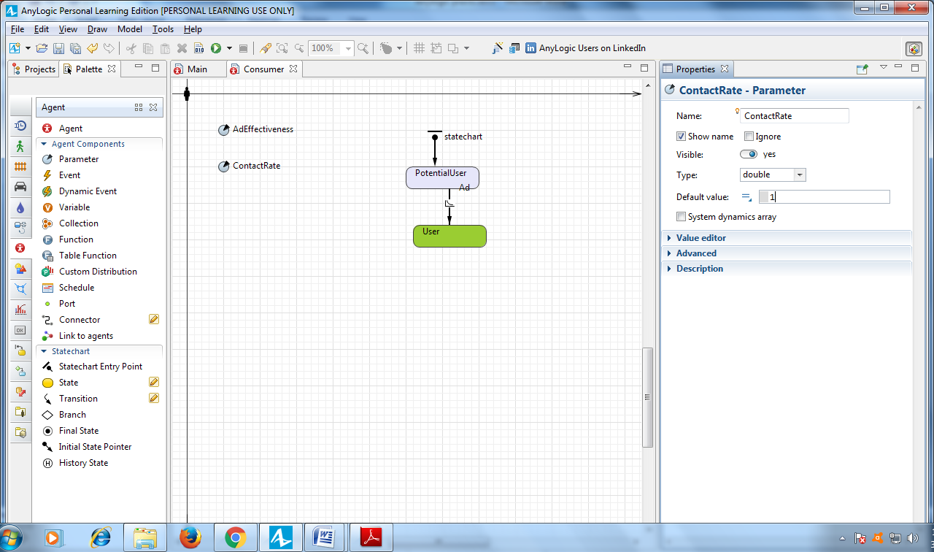

Add another parameter - AdoptionFraction - to define a person's influence on others, a number that we’ll express as the percentage of people who will use the product after they come into contact with the consumer. Leave the default parameter’s **Type**: double, and set the **Default value:** 0.01.

The Consumer diagram should look like this:

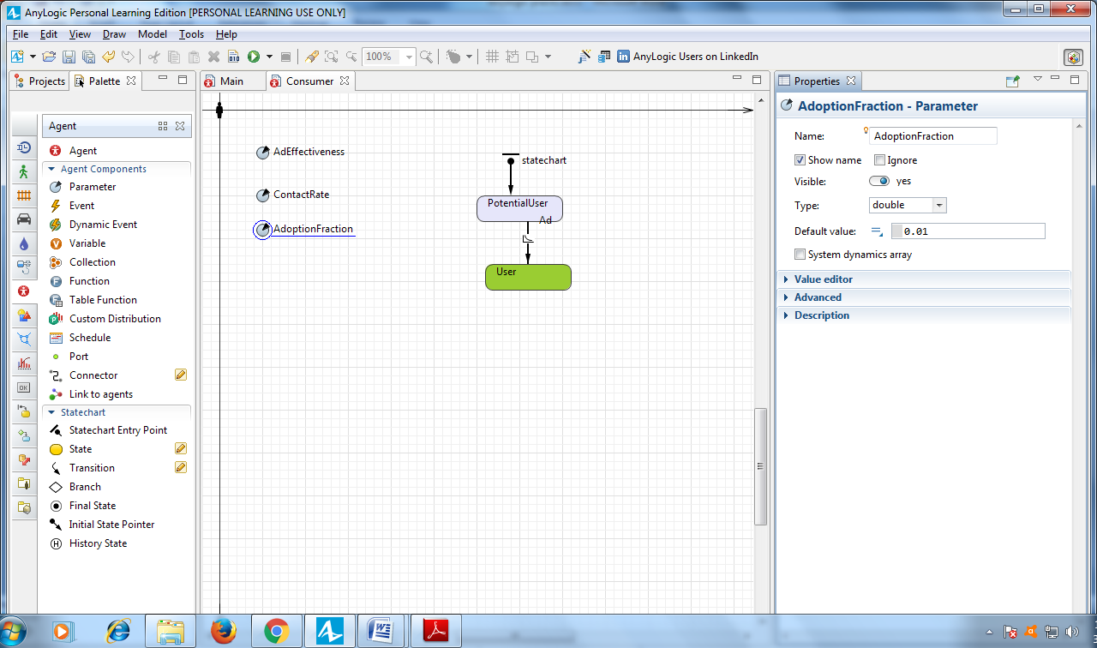

Open the Consumer diagram, and increase the User state to fit the internal transition we’ll draw inside the state on the next step.

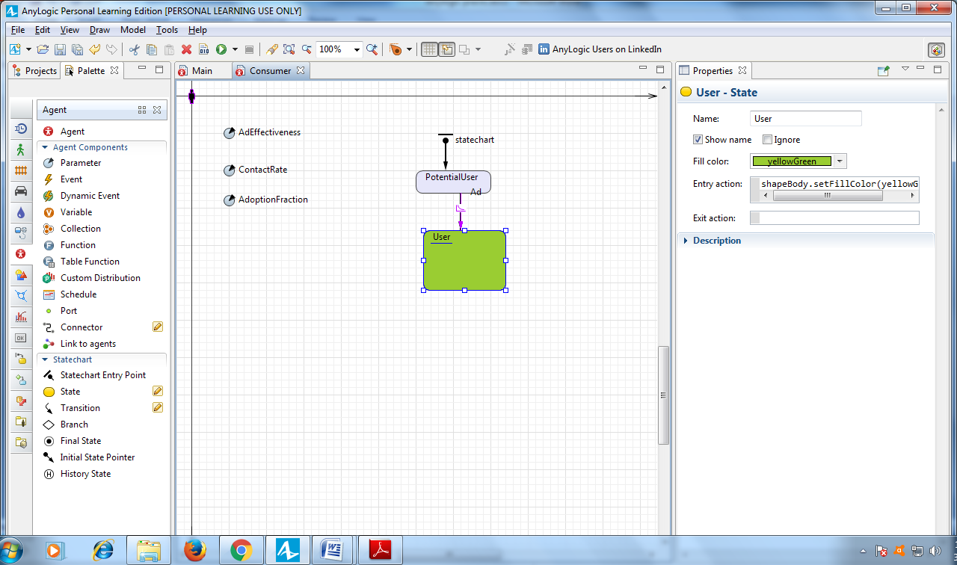

Draw an internal transition inside the User state. To draw a transition like the

one shown below, drag the **Transition** from the **Statechart** palette inside the state so the transition’s start point lies on the state border.

Afterward, you can move the transition end point to another point on the state border. To add a salient point, double-click the transition.

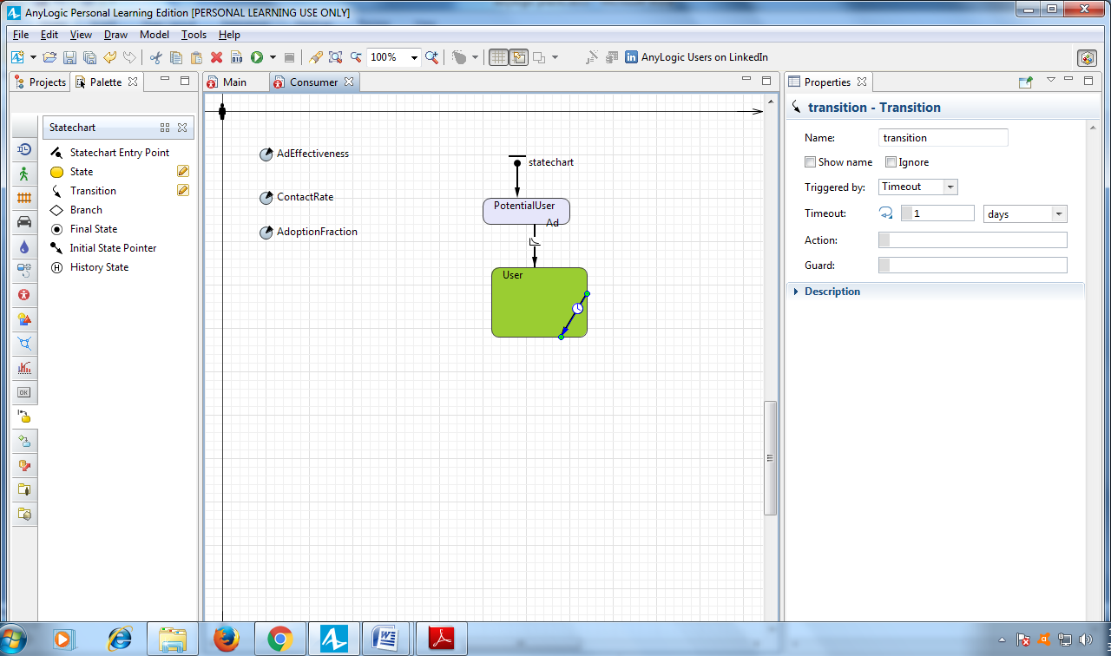

Modify the transition properties. This transition will occur with the specified **Rate** ContactRate (use code completion rather than typing the parameter’s full name). Name the transition Contact and set it to show its name.

Specify the **Action** that will be executed on triggering this transition (use the code completion to write the code): sendToRandom("Buy");

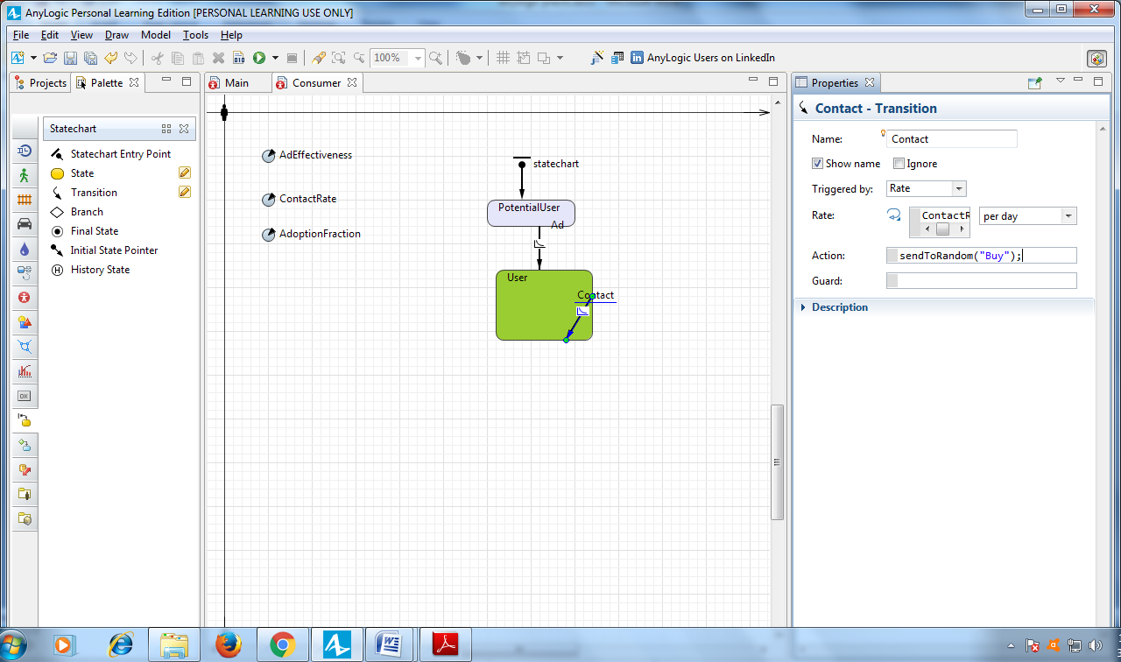

Draw another transition from PotentialUser to User state, and name it WOM (Word of Mouth). This transition will model purchases caused by word of mouth.

Modify the transition properties:

* In the **Triggered by** list, click **Message**.
* In the **Fire transition** area, select **On particular message**.
* In the **Message** field, type "Buy"
* Since we know not every contact is successful – in other words, a contact may not convince the potential user to buy our product – we’ll use AdoptionFraction to make successful contacts less common. Specify the transition’s **Guard:** randomTrue(AdoptionFraction)

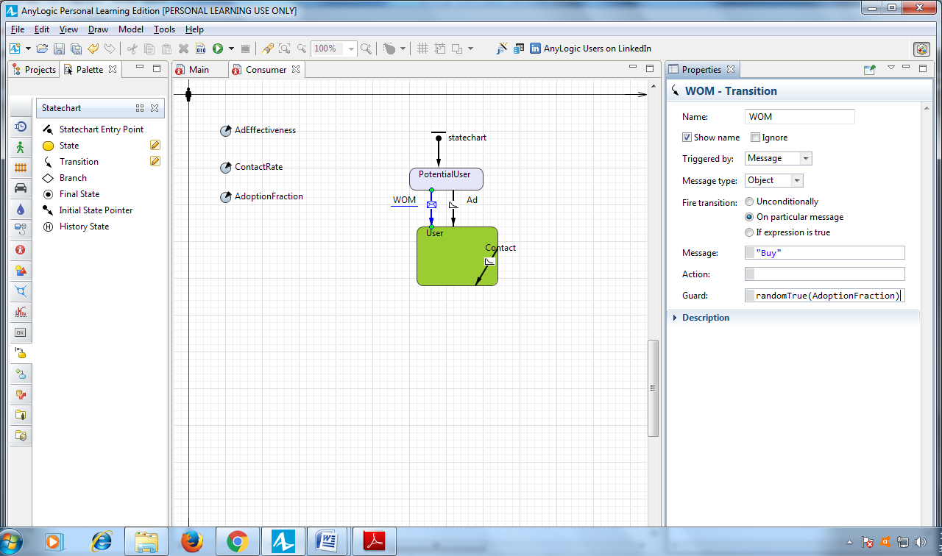

In the **Projects** view, you may see an asterisk near the model item that shows your model has unsaved changes. On the toolbar, click **Save** to save your model.

Run the model.

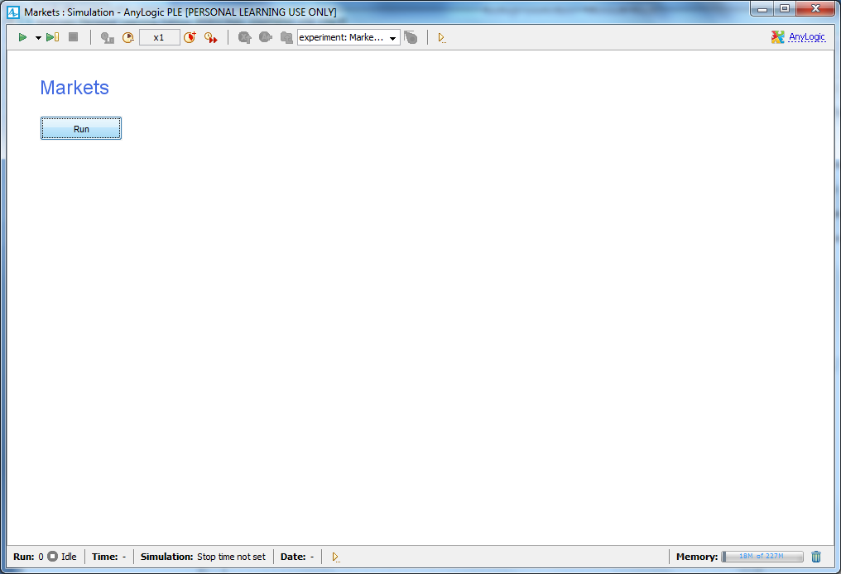

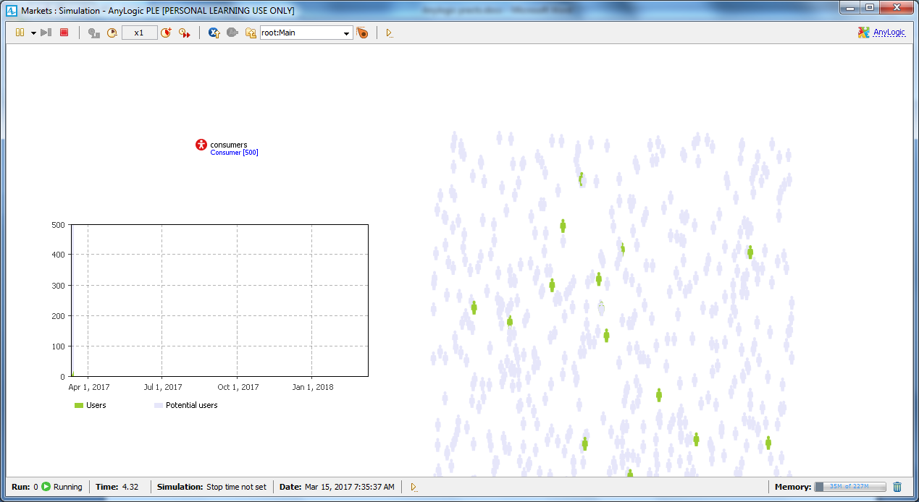

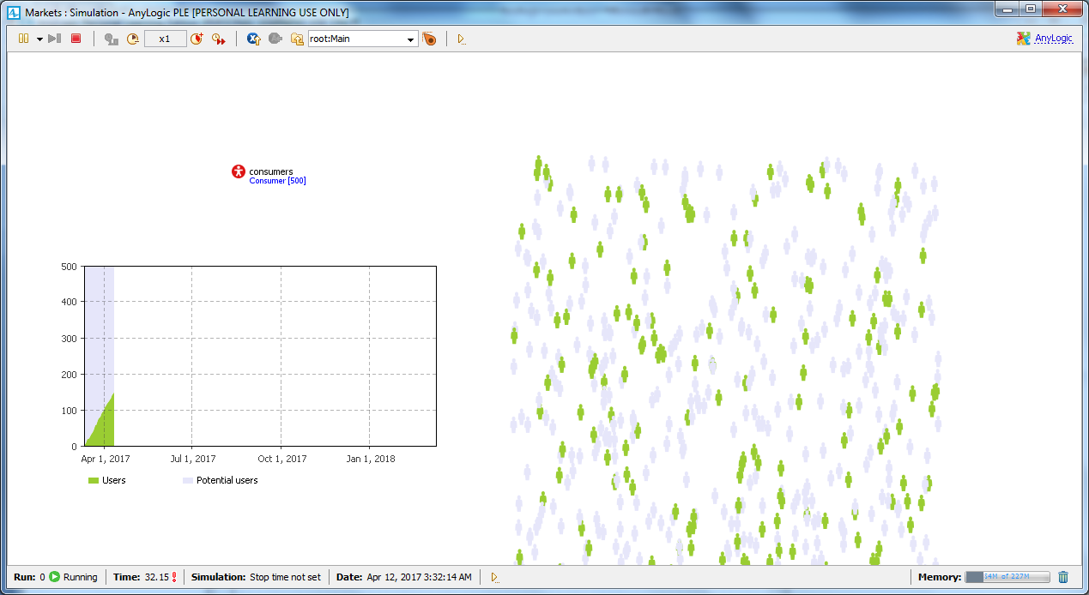

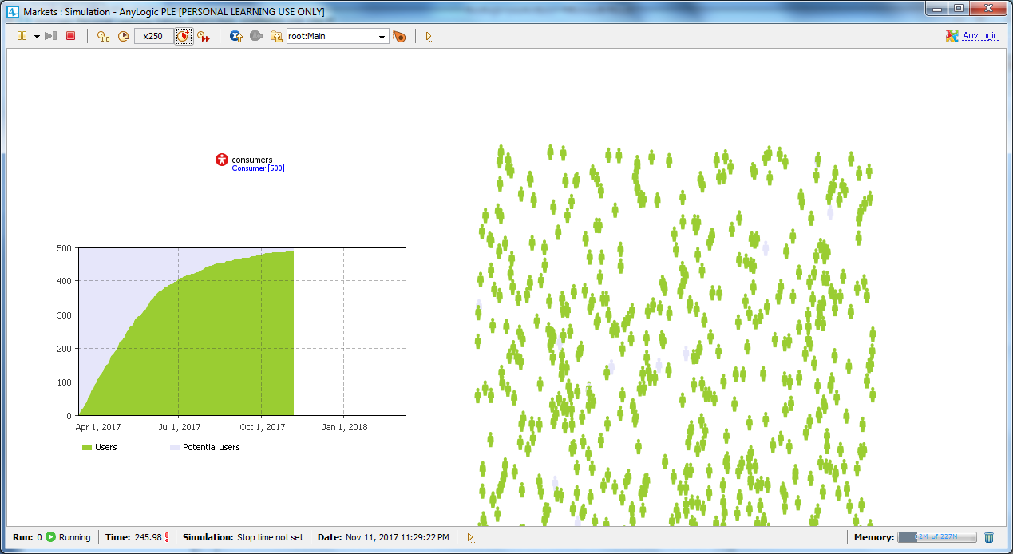

**Considering product discards**

Open the Consumer diagram and add a DiscardTime parameter

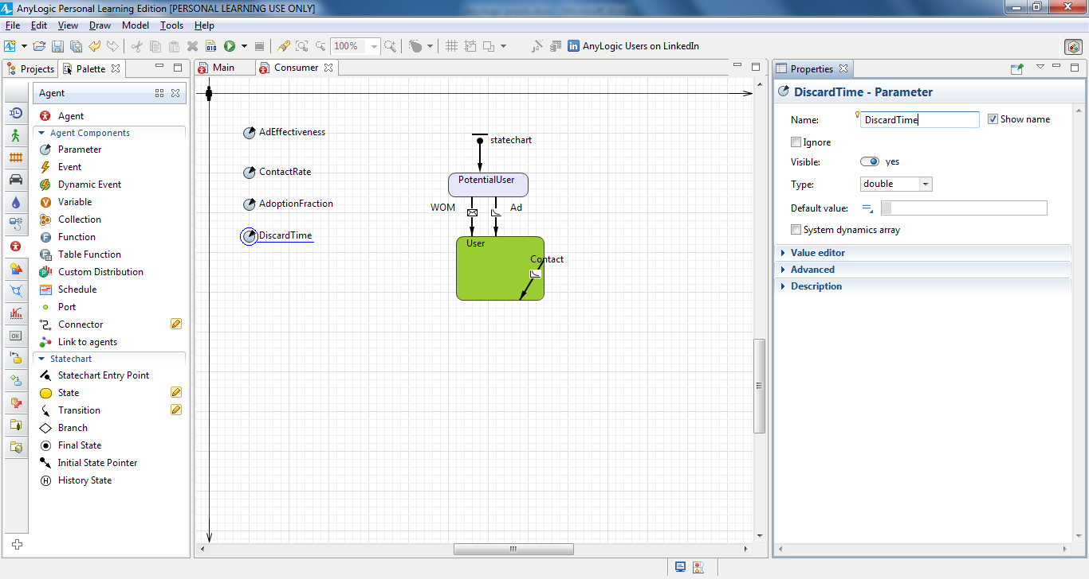

This parameter will define our product's lifespan. Choose **Time** as the parameter’s **Type**, click **months** in the **Unit** list, and type 6 as the **Default value**.

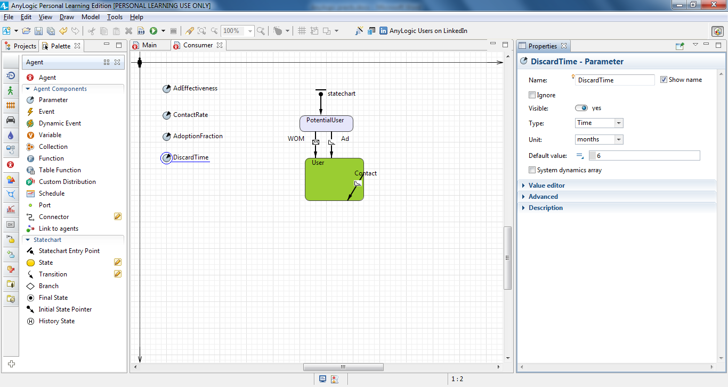

Draw a transition from User to PotentialUser state to model product discards.

To draw a transition with salient points like those shown in the figure, double-click the **Transition** element in the **Statechart** palette (this should change the element’s icon in the palette to ), click the transition’s source state User, click at the salient point places, and click the target state PotentialUser**.**

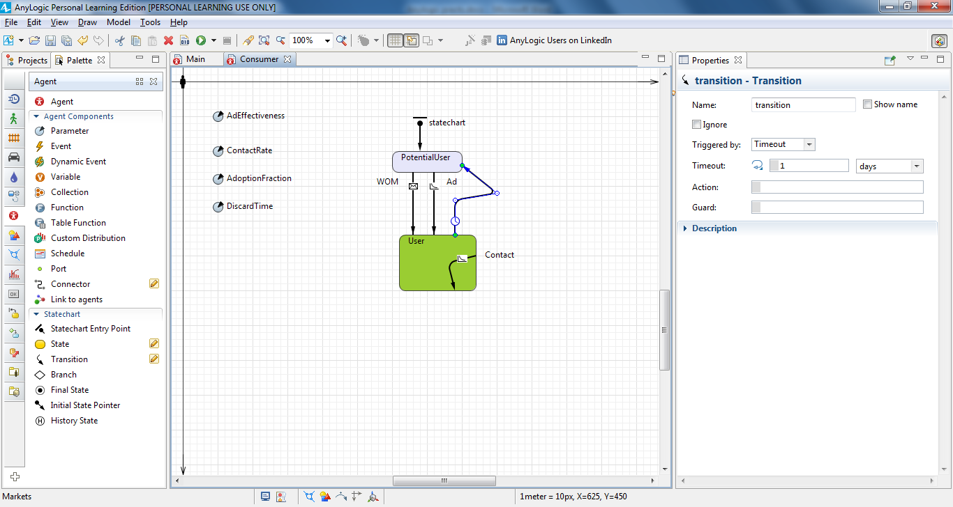

Name the transition Discard and set it to be triggered by a constant timeout DiscardTime. In the list to the right, click **months**.

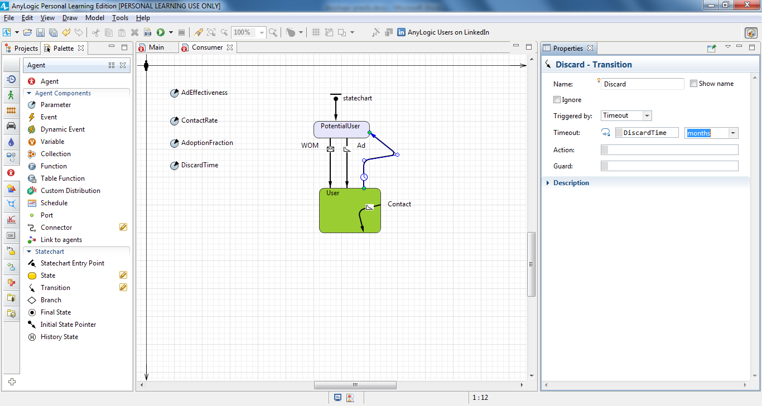

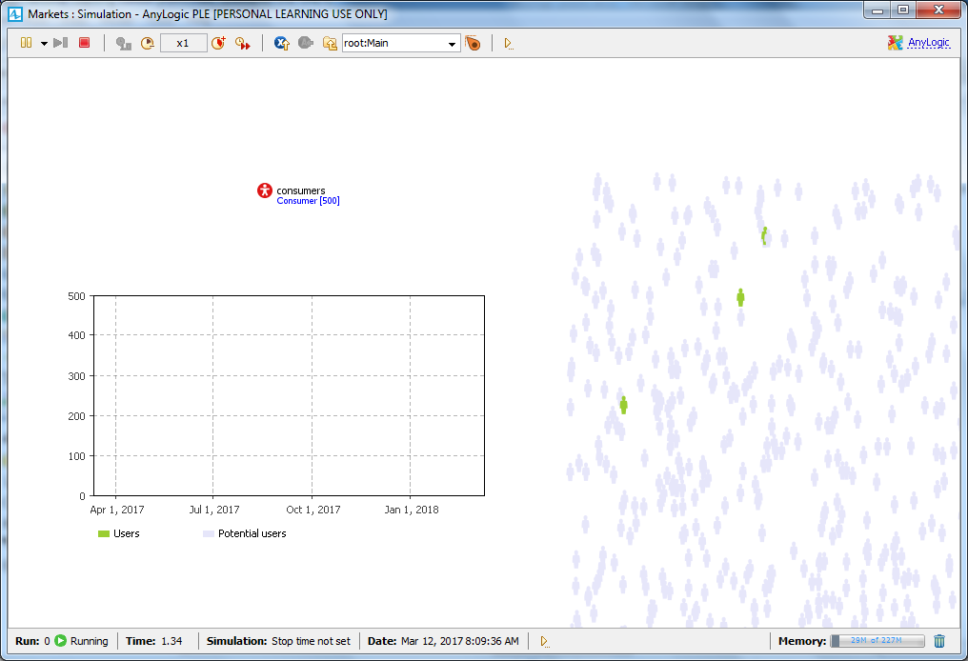

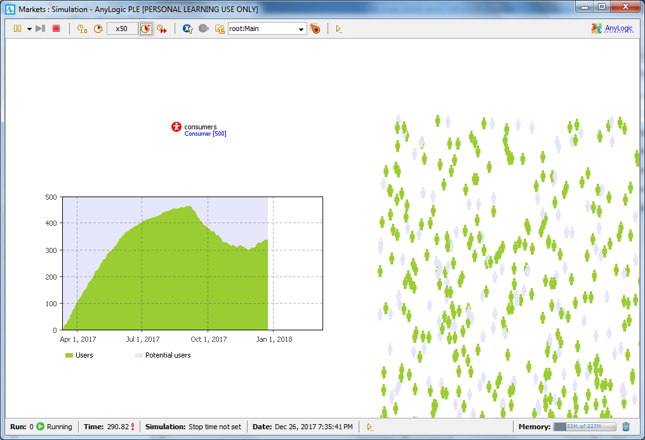

**Considering delivery time**

Prepare a place for another state between PotentialUser and User by moving the User state toward the bottom of the screen.

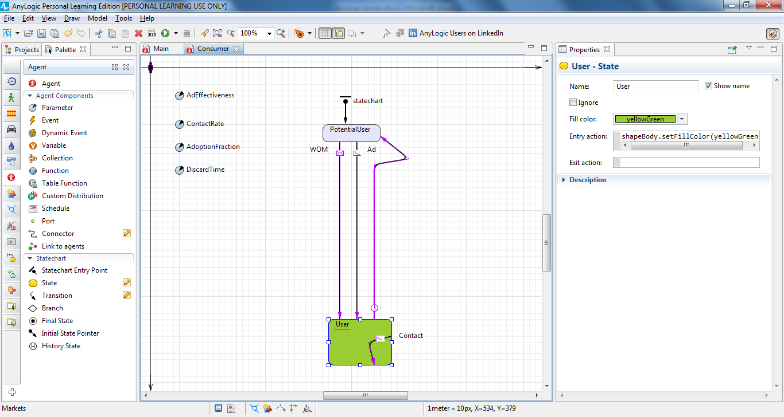

Disconnect the User state from the transitions.

Select the WOM and Ad transitions, move their end points toward the top of the screen, and disconnect the Discard transition from PotentialUser. Afterward, you’ll notice the disconnected transitions are drawn in red.

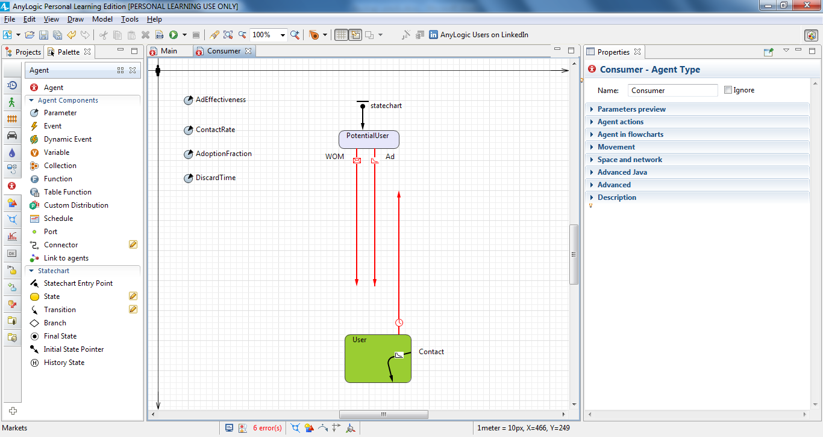

Add another **State** from the **Statechart** palette to the middle of the consumer’s statechart and name it WantsToBuy. Consumers in this state have decided to purchase the product, but they have not done so.

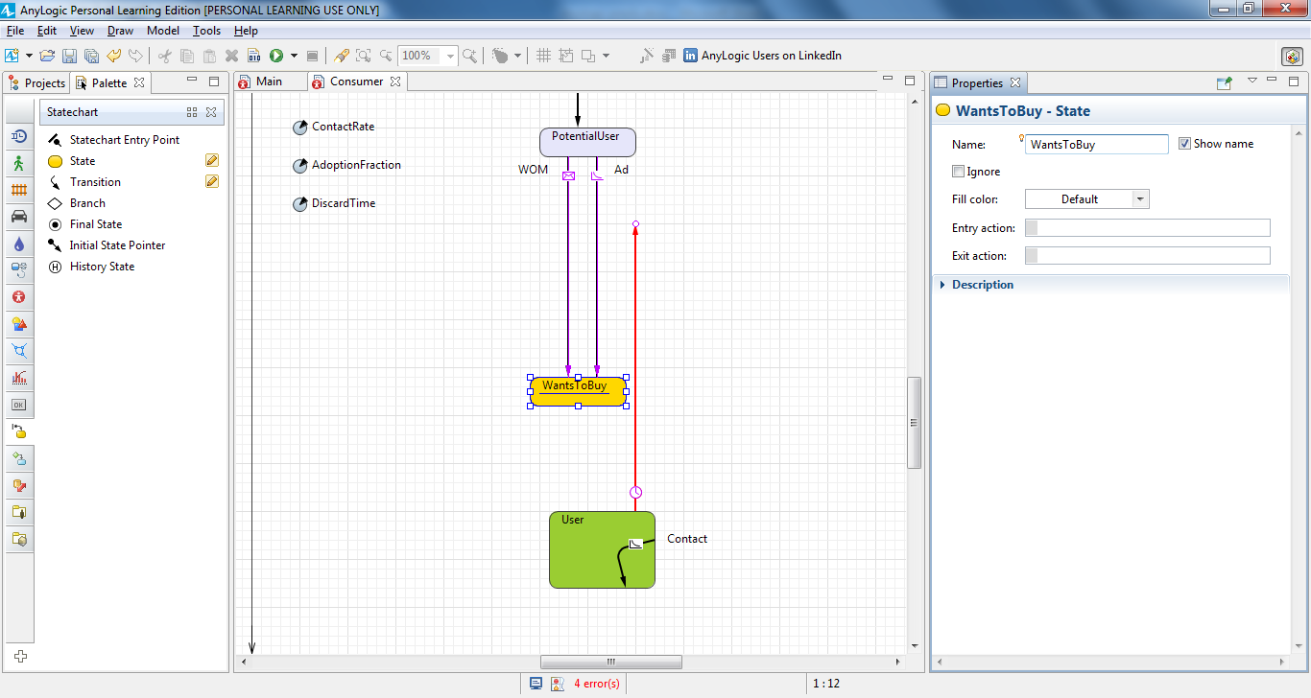

Reconnect transitions to the middle state: the WOM, Ad, and Discard transitions should now end in the WantsToBuy state.

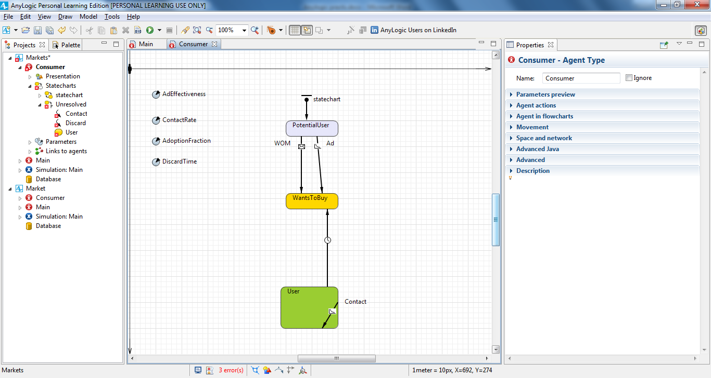

Modify WantsToBuy similar to other states:

**Fill color**: gold

**Entry action**: shapeBody.setFillColor(gold)

Add a transition from WantsToBuy to User state to model the product

shipment and name it Purchase.

Let’s assume it typically takes a user two days to get the product. This means once the consumer’s statechart enters the state WantsToBuy, it will proceed to the state User with a two-day delay. With this in mind, set 2 days timeout for the Purchase transition:

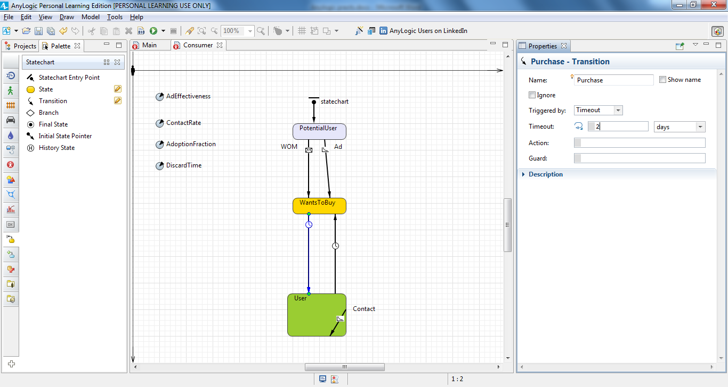

Define one more statistics function to count the product’s market-driven demand. In the editor of Main, click the consumers, go to the **Statistics** properties section, and add a statistics item: NWantToBuy with condition item.inState(Consumer.WantsToBuy)

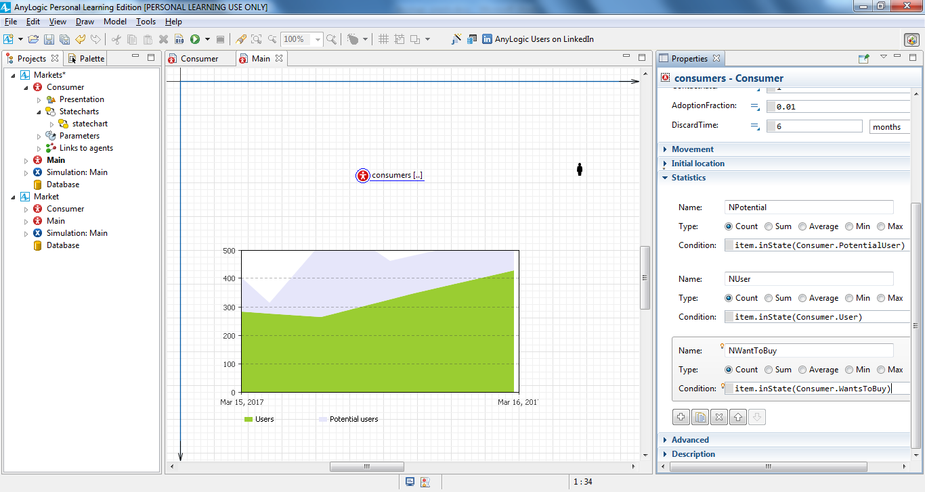

On Main, select the time stack chart, and add another data item to be displayed with the chart: consumers.NWantToBuy() with the title Want to buy and color gold.

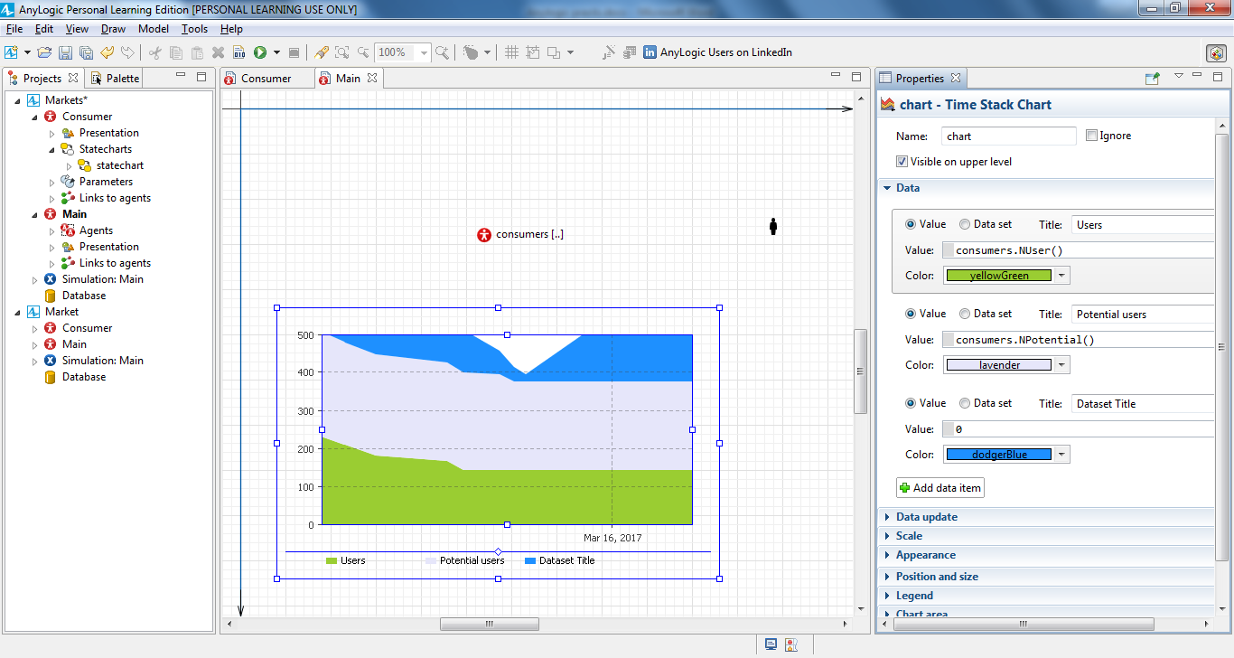

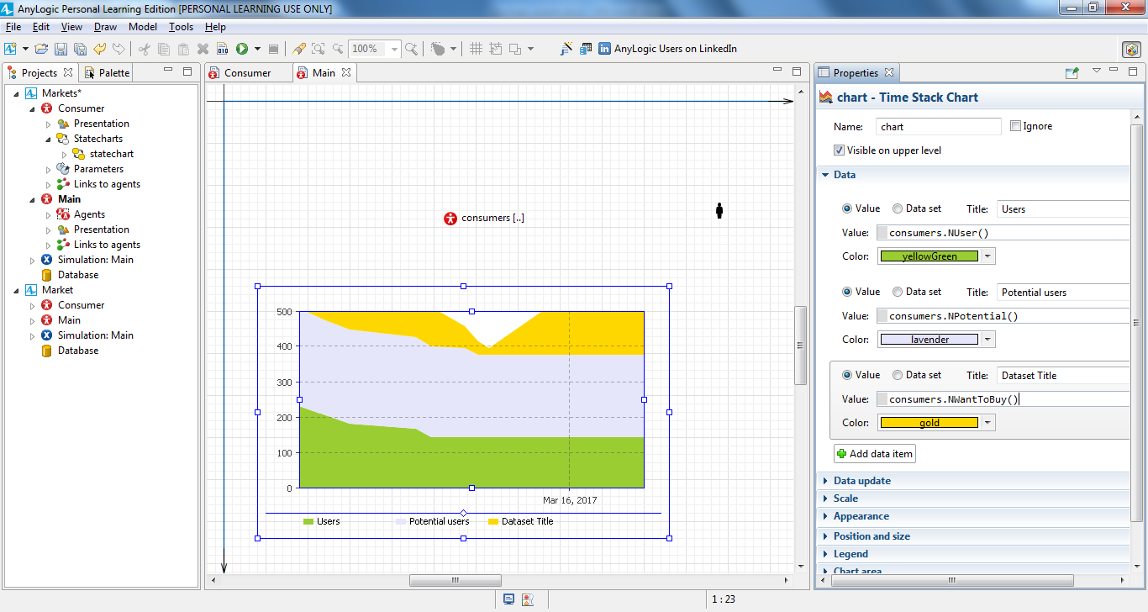

Make the newly-defined data item second in the list by selecting the item’s

section and clicking the “up” button .

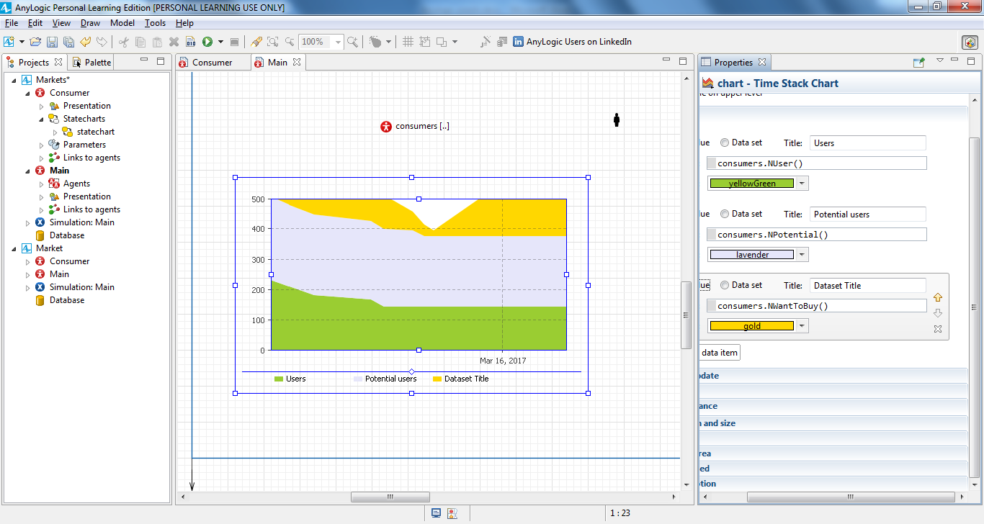

Run the model, and you’ll notice AnyLogic displays the number of consumers who are waiting for the product in yellow.

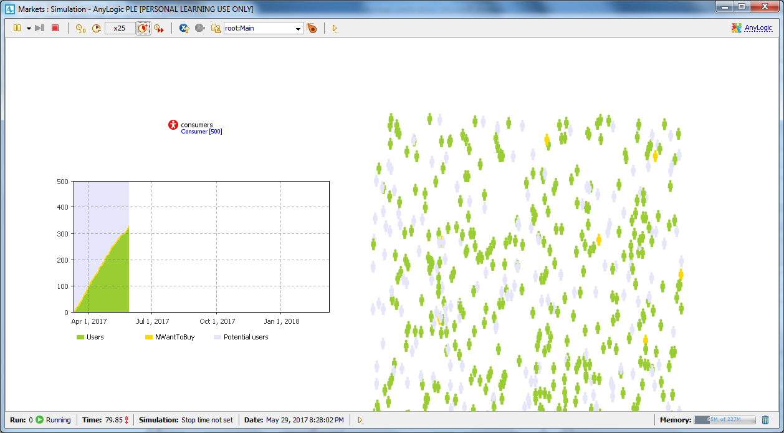

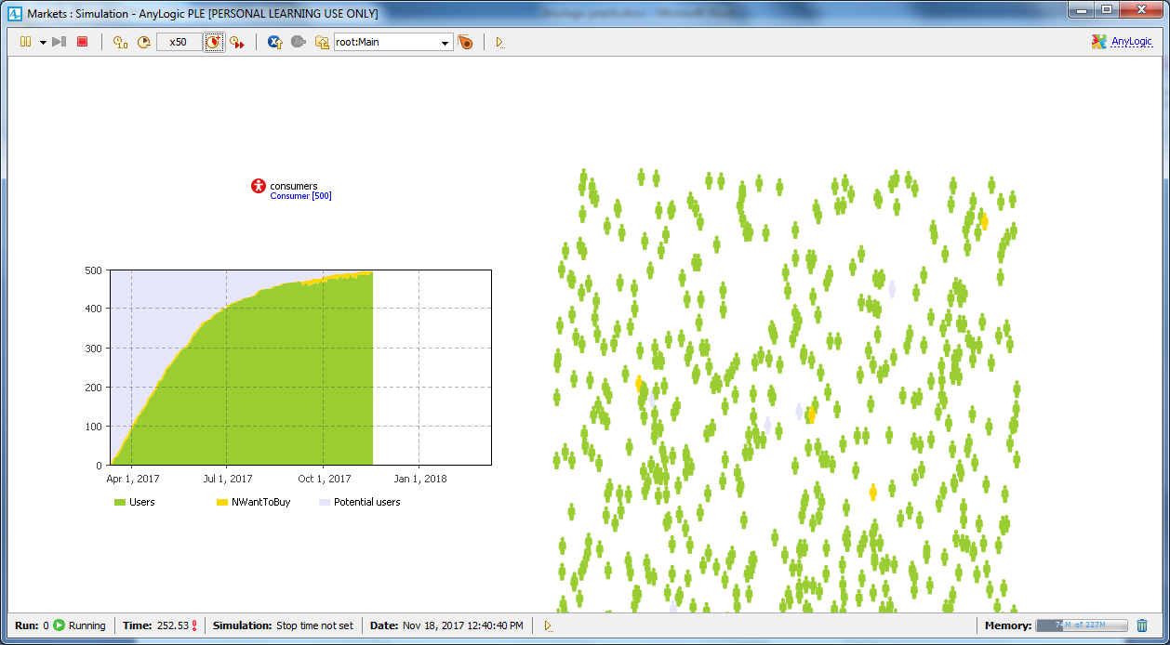

# Practical No. 3

## Problem statement

Design and develop agent based model by

* Creating the agent population
* Defining the agent behavior
* Adding a chart to visualize the model output
* Adding word of mouth effect
* Considering product discards
* Consider delivery time
* **Simulating agent/Consumer impatience**
* **Comparing model runs with different parameter values**

## Solution

Configure the parameters. MaxWaitingTime defines the maximum time a consumer will wait for the product for 7 days.

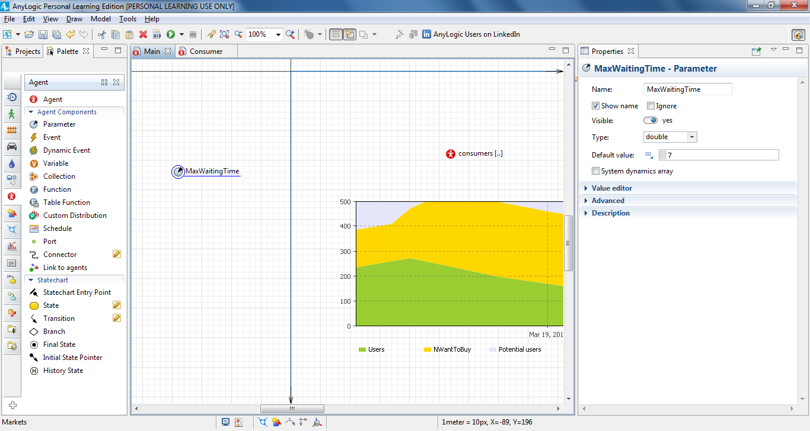

Set the other parameter, MaxDeliveryTime to 25 days to reflect our assumption it may take up to 25 days to deliver a product.

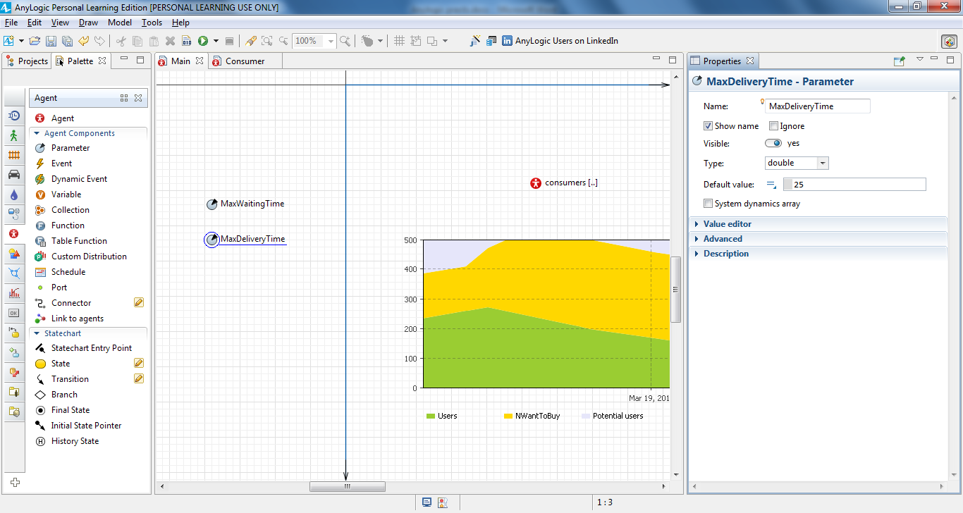

We assume it takes between one and 25 days – with an average of two days – to deliver the product. With that in mind, let's change the delivery time from a fixed two day delivery period to the stochastic expression that describes this pattern.

Open the Consumer diagram and select the Purchase transition. We want to change the transition’s timeout expression, and we’ll do that by using a wizard to choose the distribution function and insert the function’s name in the property. To substitute the existing value, use your mouse to select the existing **Timeout** expression.

Click the **Choose Probability Distribution…** toolbar button.

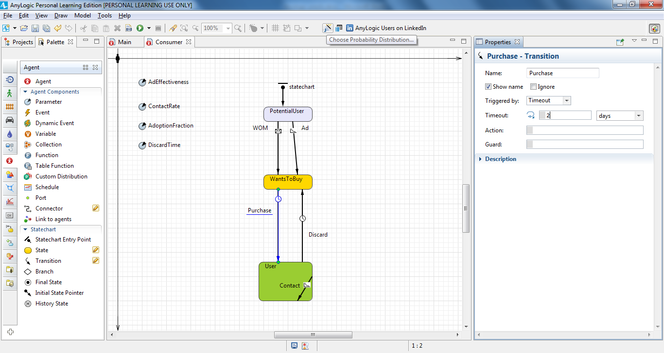

You’ll see the **Choose Probability Distribution…** dialog box.

The **Choose Probability Description** screen allows you to view the list of supported distributions, and you can click any name in the list to view the distribution’s description.

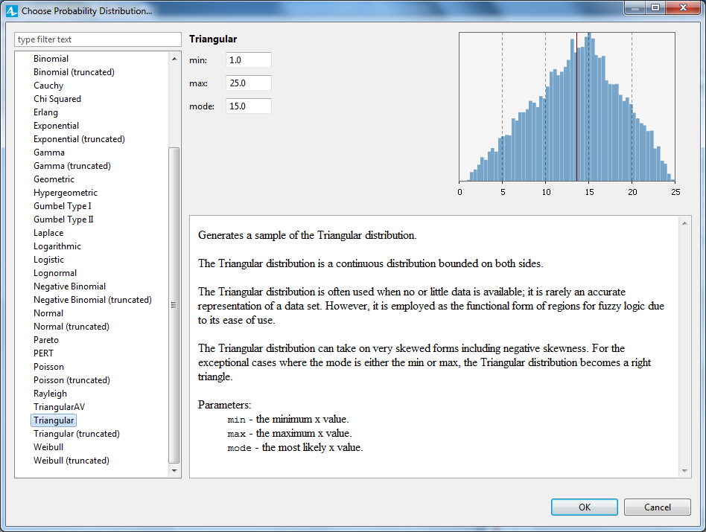

Choose triangular in the list. Set **min**, **max** and **mode** parameters equal to 1, 25, 2 respectively. In the upper right, you’ll see PDF instantly built for the distribution with the specified parameters. Click **OK** when finished.

You’ll see the expression triangular(1, 25, 2) automatically inserted as the timeout value. Let’s modify the line to triangular(1, main.MaxDeliveryTime, 2)

Here main is how we access the Main agent from the consumer agent.

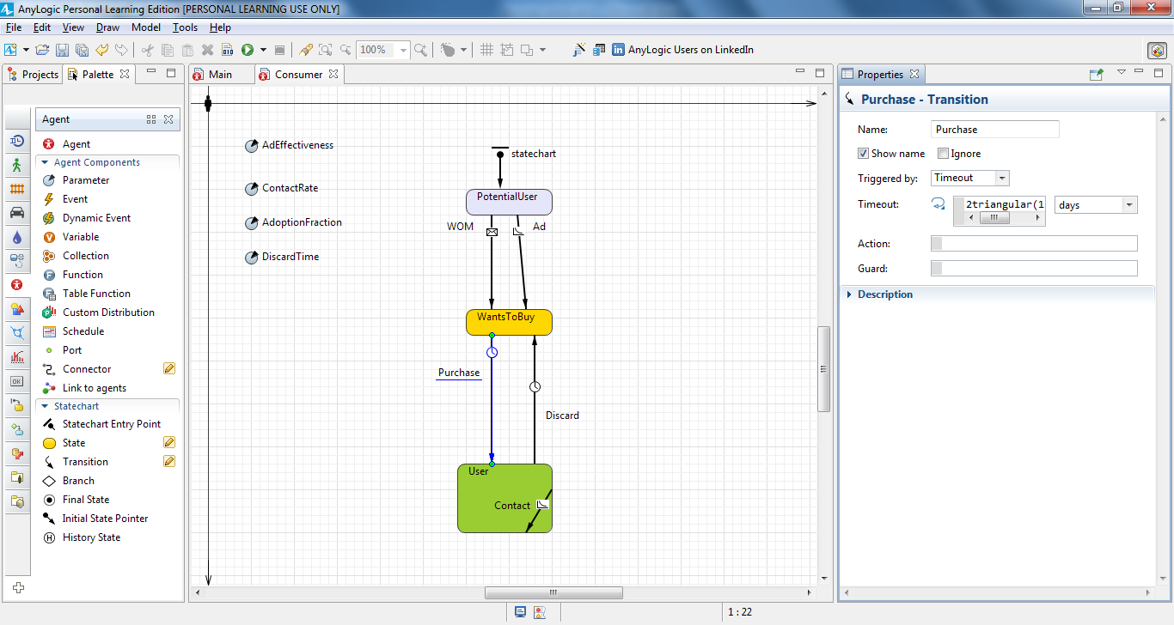

Draw the last transition CantWait that goes from WantsToBuy to PotentialUser state. This transition will model how a consumer’s impatience causes them to change their purchase decision, and the Consumer diagram will look like this:

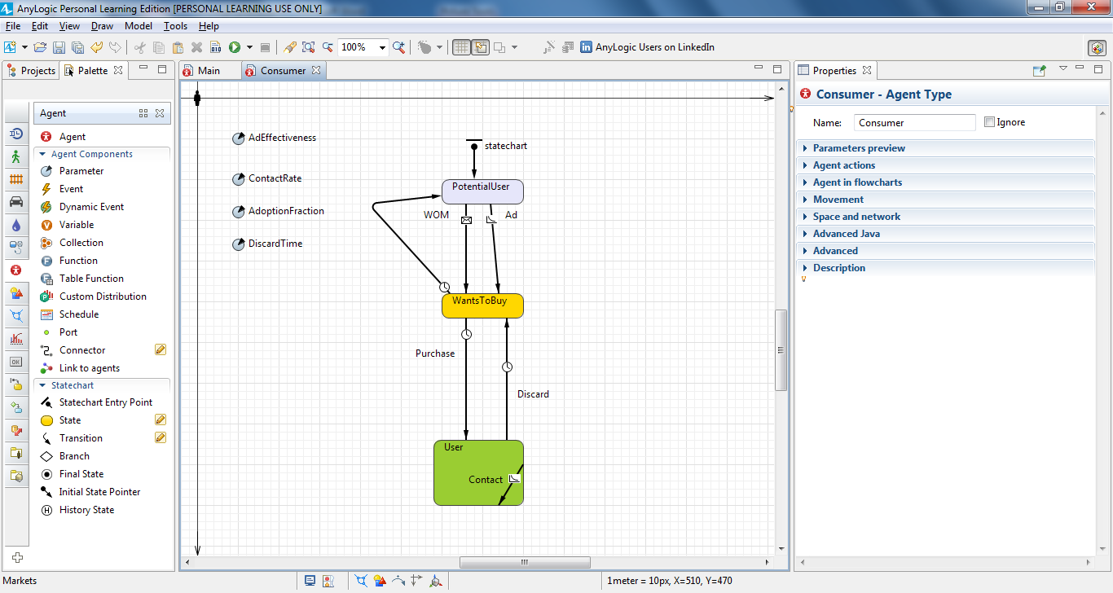

Modify the transition properties so it is triggered by **Timeout** which equals triangularAV(main.MaxWaitingTime, 0.15) **days**

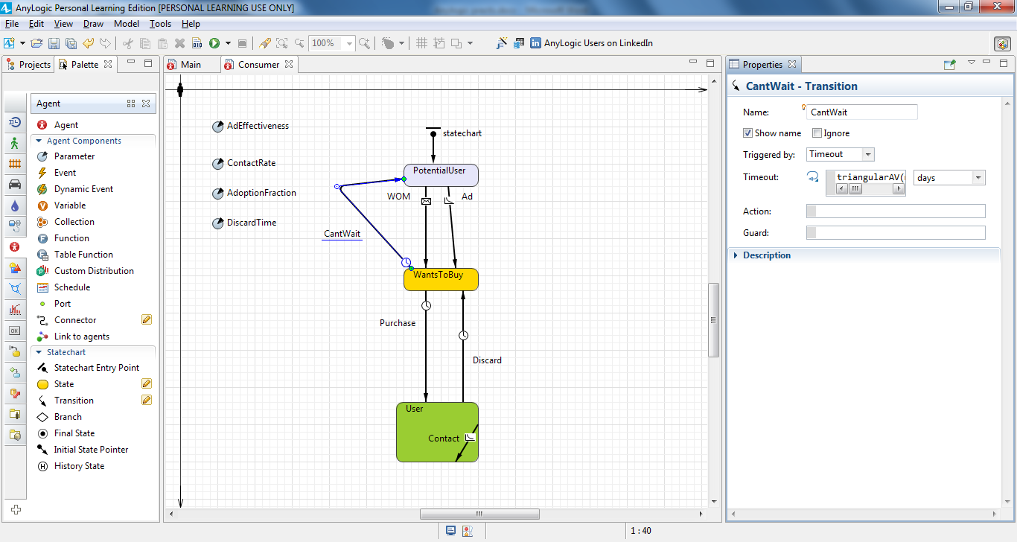

Rather than setting the maximum waiting time equal to constant MaxWaitingTime, we assume it follows a triangular distribution with an average of one week and a possible variation to up to 15 percent.

Go back to Main diagram. Open the **Controls** palette and drag two **Sliders** on to the diagram below the chart. We’ll eventually link the sliders to our two parameters.

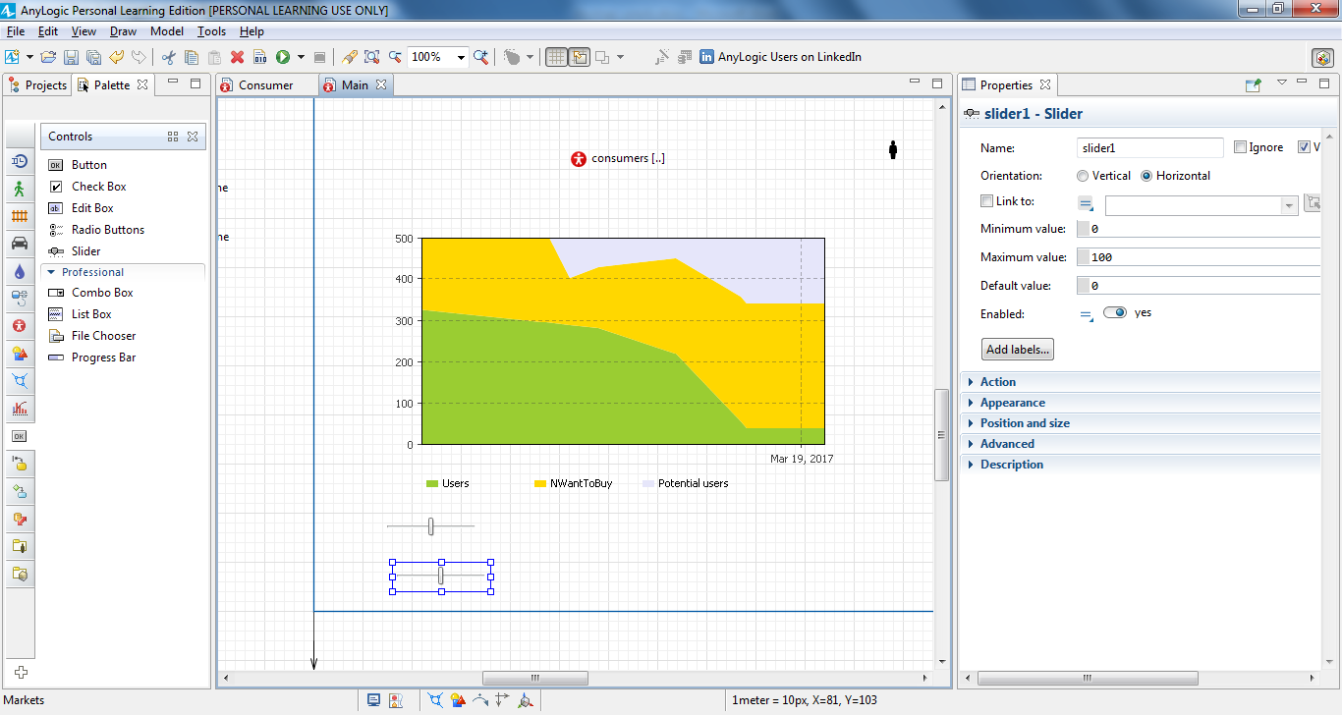

Select the checkbox **Link to** and select the parameter MaxWaitingTime to the right.

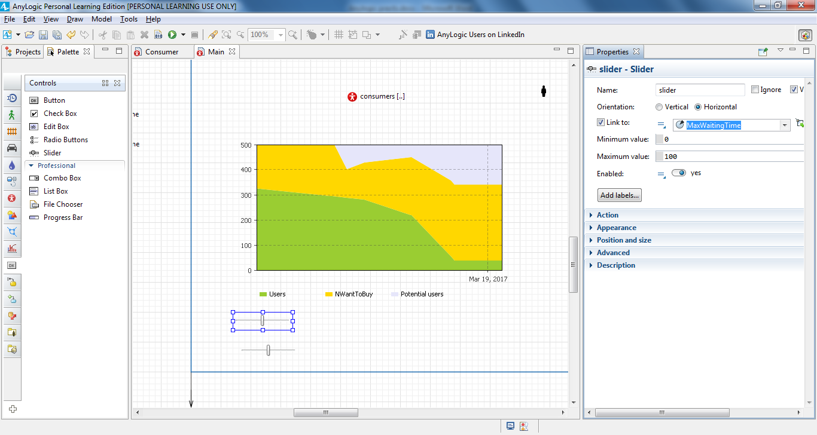

Set the slider’s **Minimum** and **Maximum values**. The parameter value can vary within the range you define here, and we’ll set 2 as **Minimum** and 15 as **Maximum value**.

Finally, click the **Add labels…** button to display the slider’s minimum, maximum, and current values at runtime (the min, value, and max text shapes will appear beneath the slider).

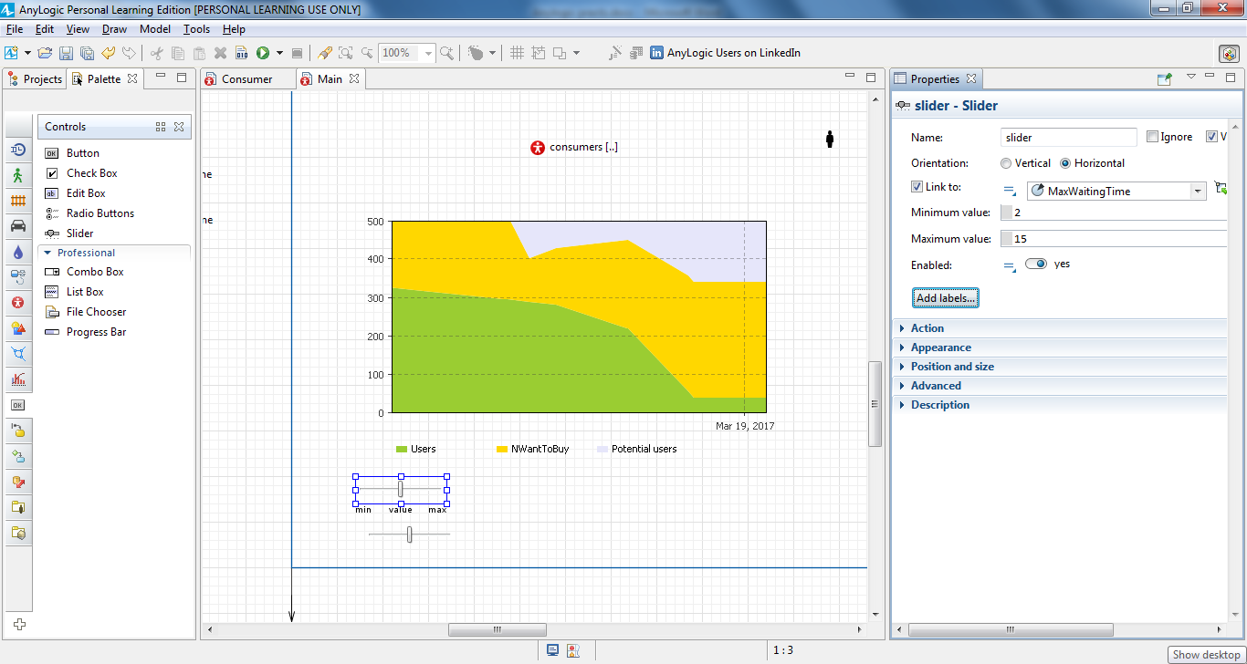

Select the checkbox **Link to** and select the parameter MaxDeliveryTime to the right.

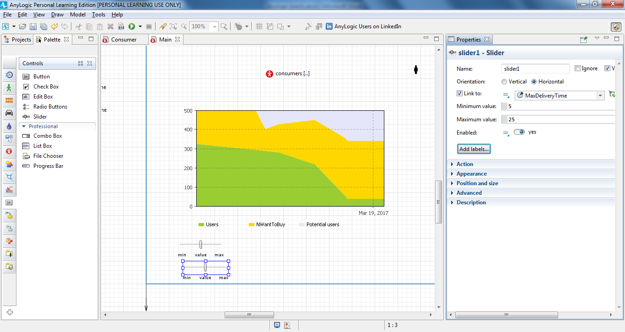

Open the **Presentation** palette, drag two **Text** shapes on to the diagram, and place them above the sliders. Let’s configure the titles of these controls.

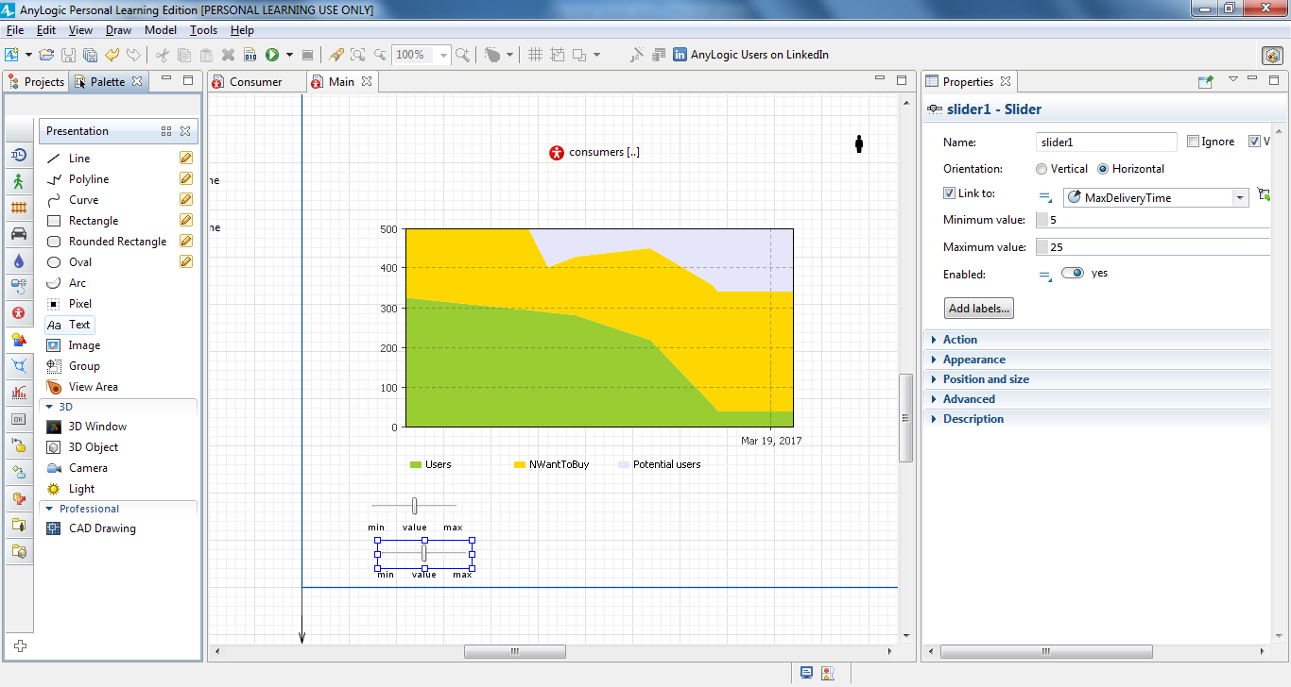

In the properties view, in the **Text** section, enter the text that the model will display. Using text shapes, name one slider Maximum waiting time and the other slider Maximum delivery time.

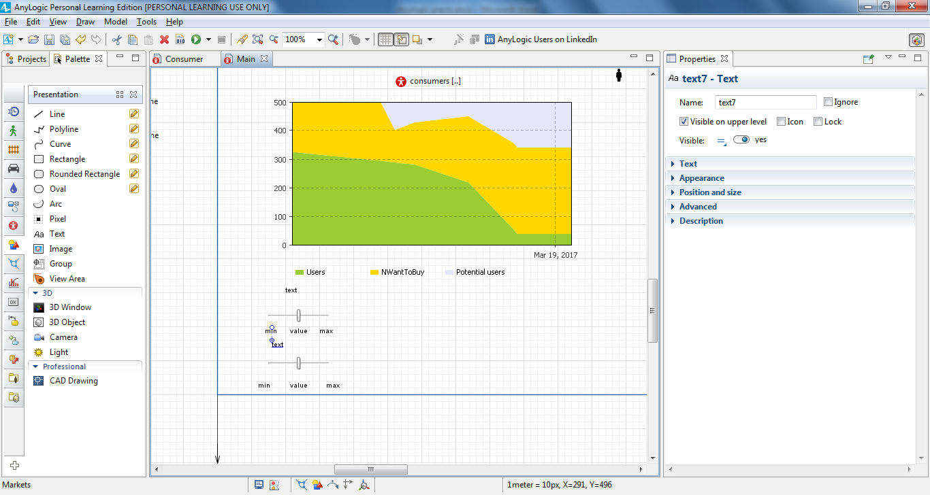

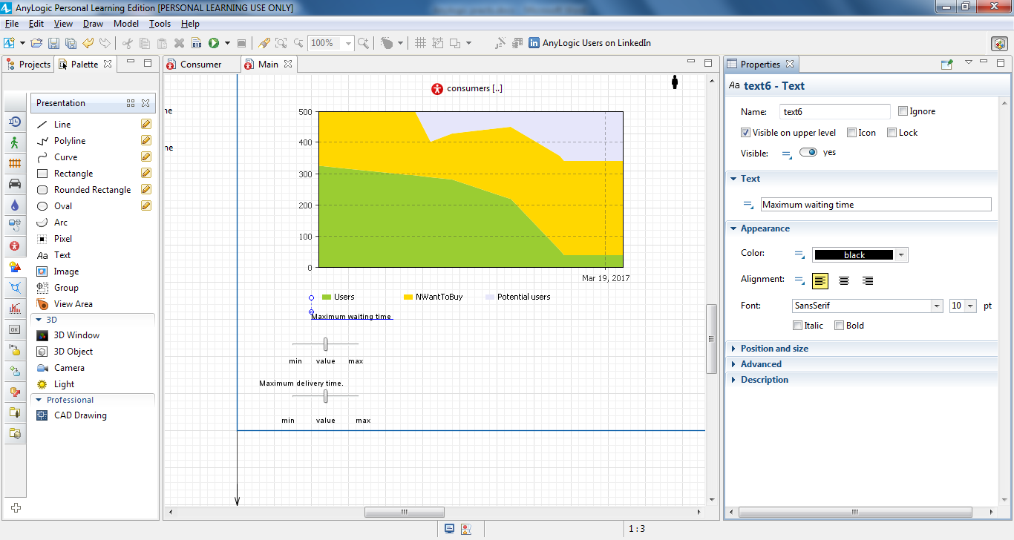

Run the model and observe the behavior. As you use the sliders to change the maximum waiting time or delivery time, you’ll see your changes reflected in consumer behaviors and whole adoption dynamics.

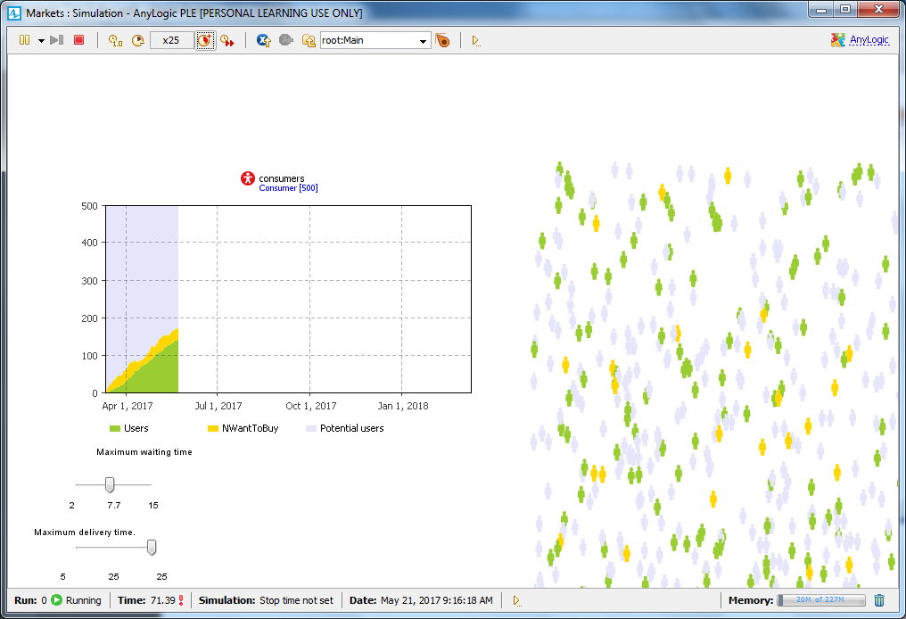

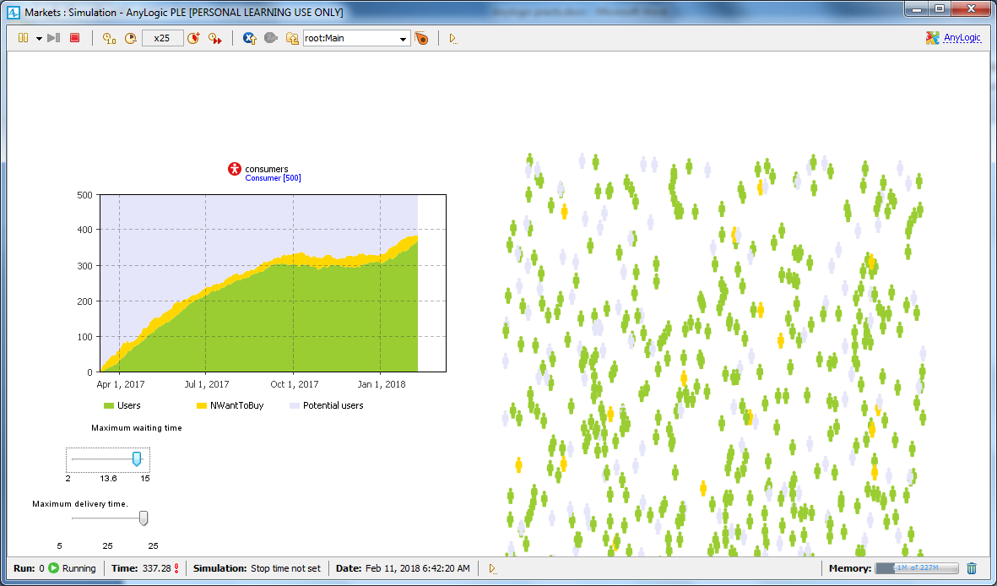

**Comparing model runs with different parameter values**

Open the Main diagram and add a **Data Set** from the **Analysis** palette. Name it usersDS

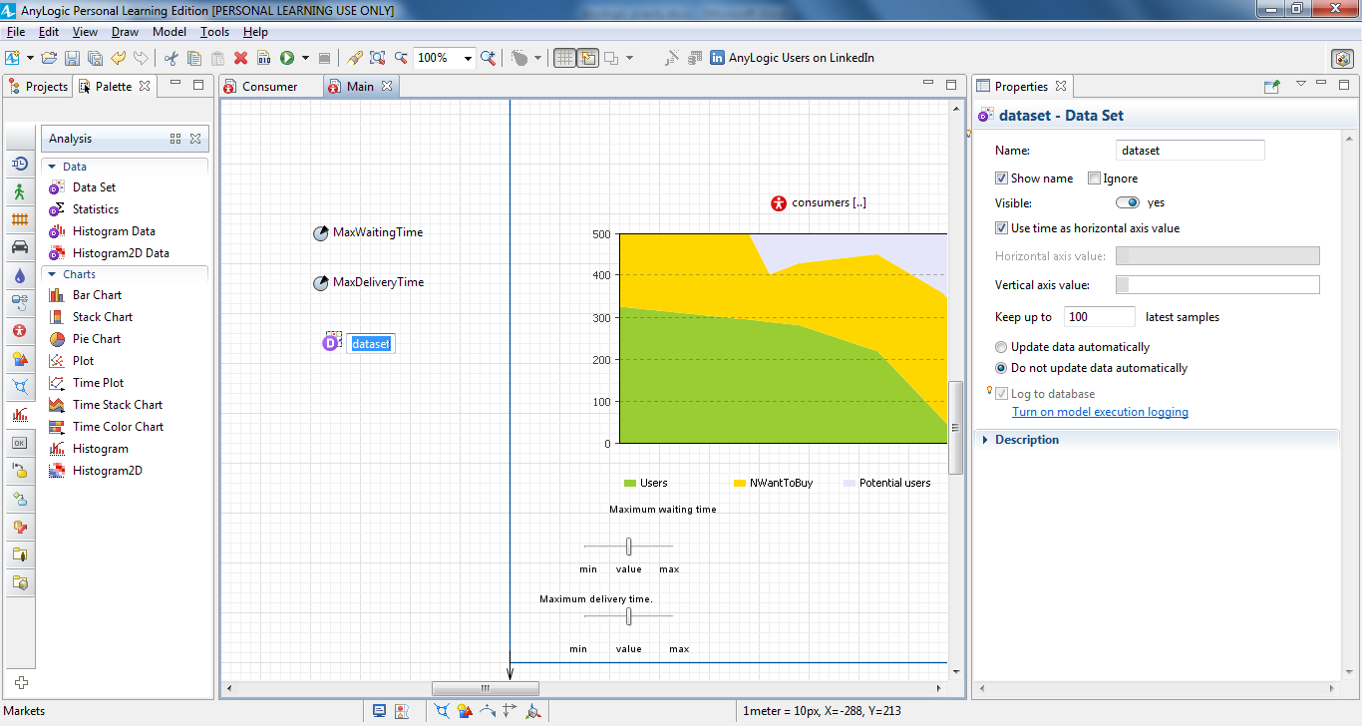

**Data Set** is capable of storing 2D (X,Y) data of type double. We want this dataset to store the history of product sales dynamics. We’ll store data samples, each with a timestamp and the current number of the product users.

Set the value that the dataset will store. In the **Vertical axis value** property, type: consumers.NUser().

The dataset keeps a limited number of recent latest data items, and we’ll limit our sample size to 500. Set the dataset to **Keep up to** 500 **latest samples**. Set it to **Update data automatically** with the default **Recurrence time**: 1. We’ll add one data sample for one day of the model’s lifetime.

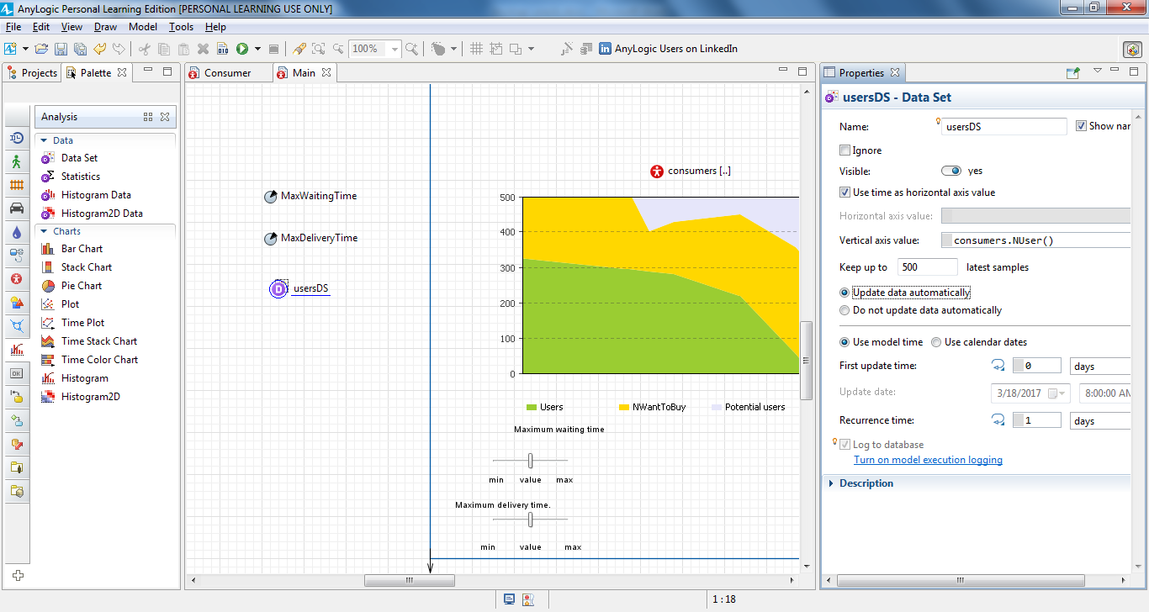

Next, make changes in the **Value editor** section for both parameters on Main diagram (MaxWaitingTime and MaxDeliveryTime). Choose Slider as **Control type**, set **Min** and **Max** values the same as we have in the sliders on Main, and if you want, change the default label (say, Maximum waiting time).

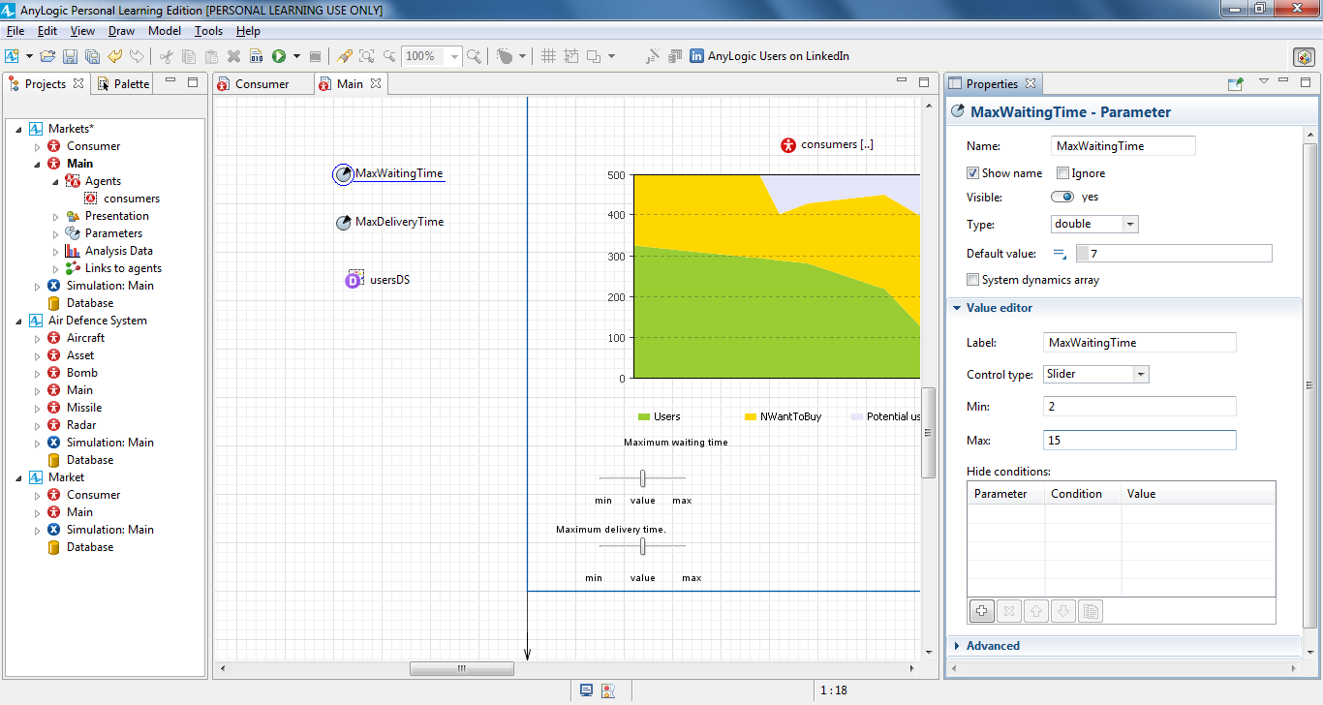

Open the **Projects** view, right-click the model item, and select **New > Experiment** from the context menu. The **New experiment** wizard will pop up.

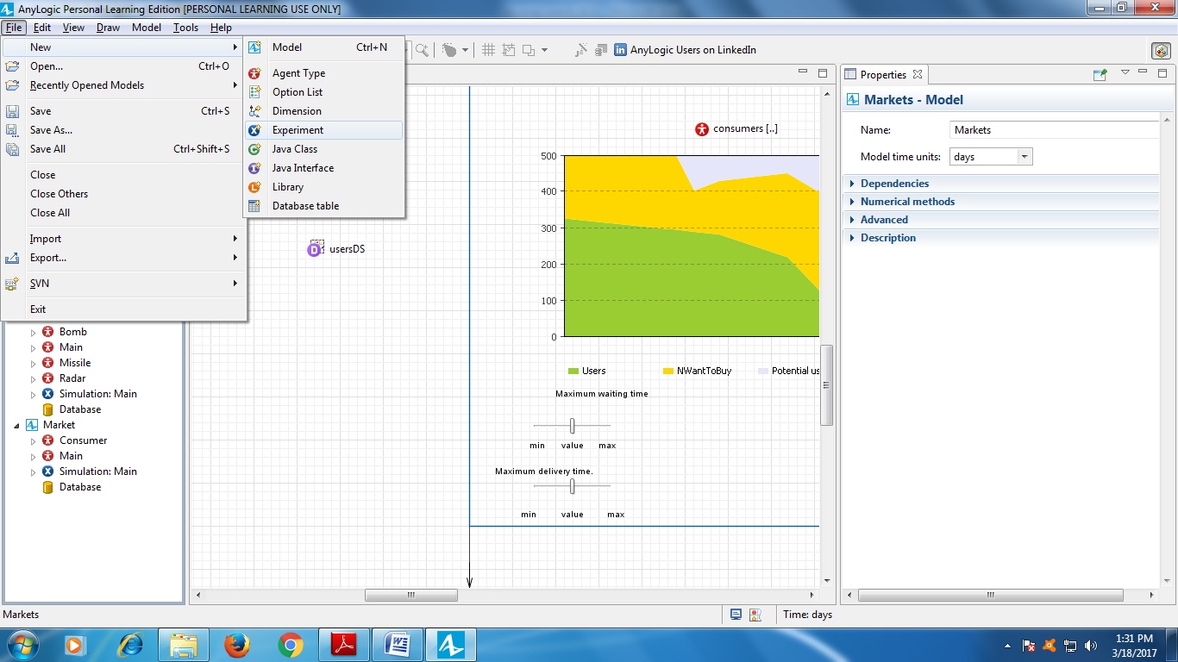

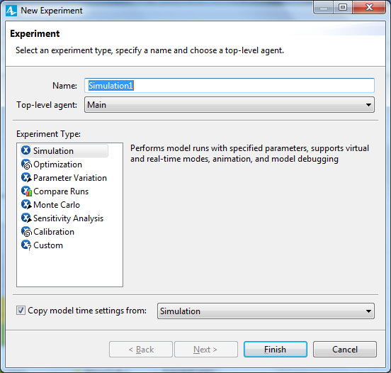

Select **Compare Runs** experiment from the list of experiment types andclick **Next**.

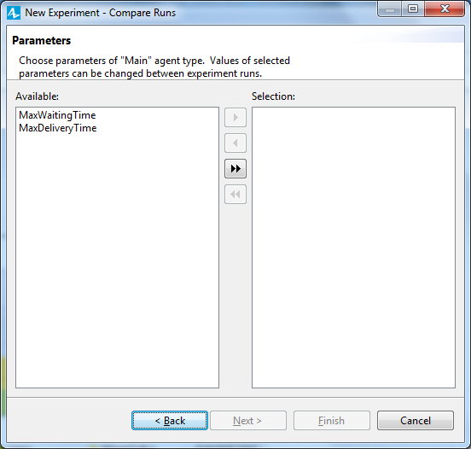

On the **Parameters** page, add both parameters to the **Selection** column. To add a parameter, select it in the **Available** list on the left and click the arrow. You can also click the button to add all the parameters. Click **Next** after both parameters are in **Selection**.

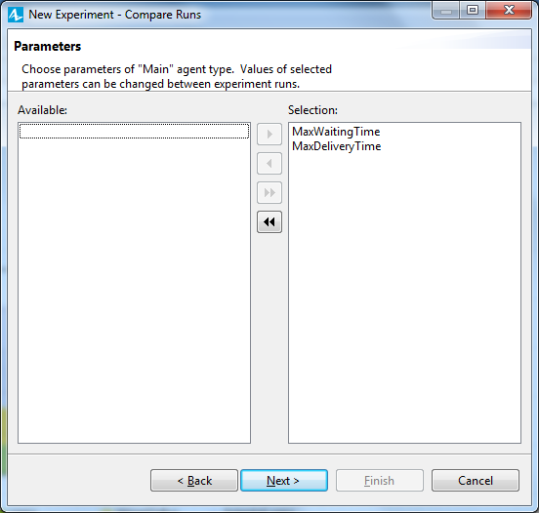

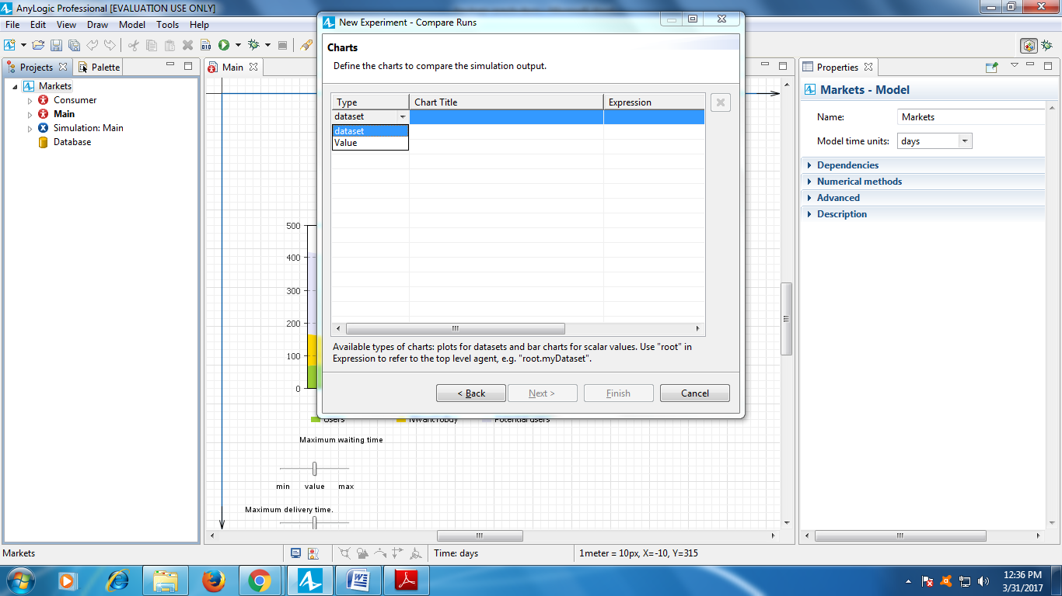

In the **Type** column, select **dataset**.

In the **Chart Title** column, type Users.

In the **Expression** column, refer to the dataset you defined in Main as root.usersDS where root is the model’s top-level agent (Main)

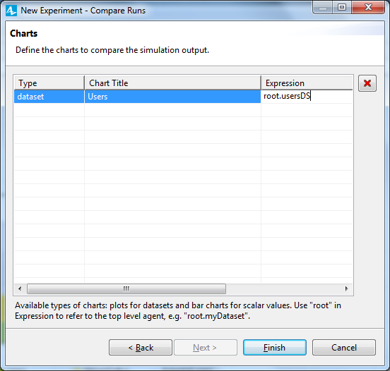

The chart will display the data collected by the dataset usersDS. Click **Finish**.

The CompareRuns experiment diagram should open automatically, and you’ll see the default user interface we created with the wizard.

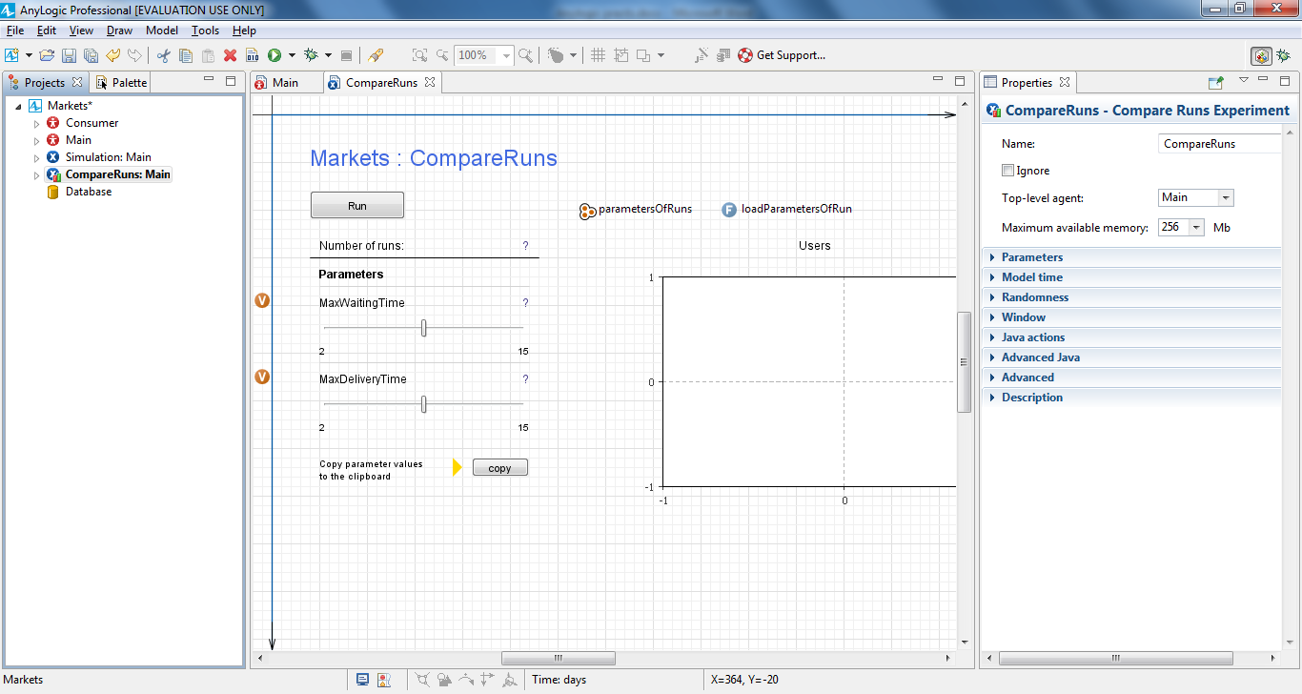

We want our experiment to simulate the model for just 500 days. To do this, select CompareRuns experiment in the **Projects** tree. In the experiment properties, open the **Model time** properties section, and type 500 in the **Stop time** field.

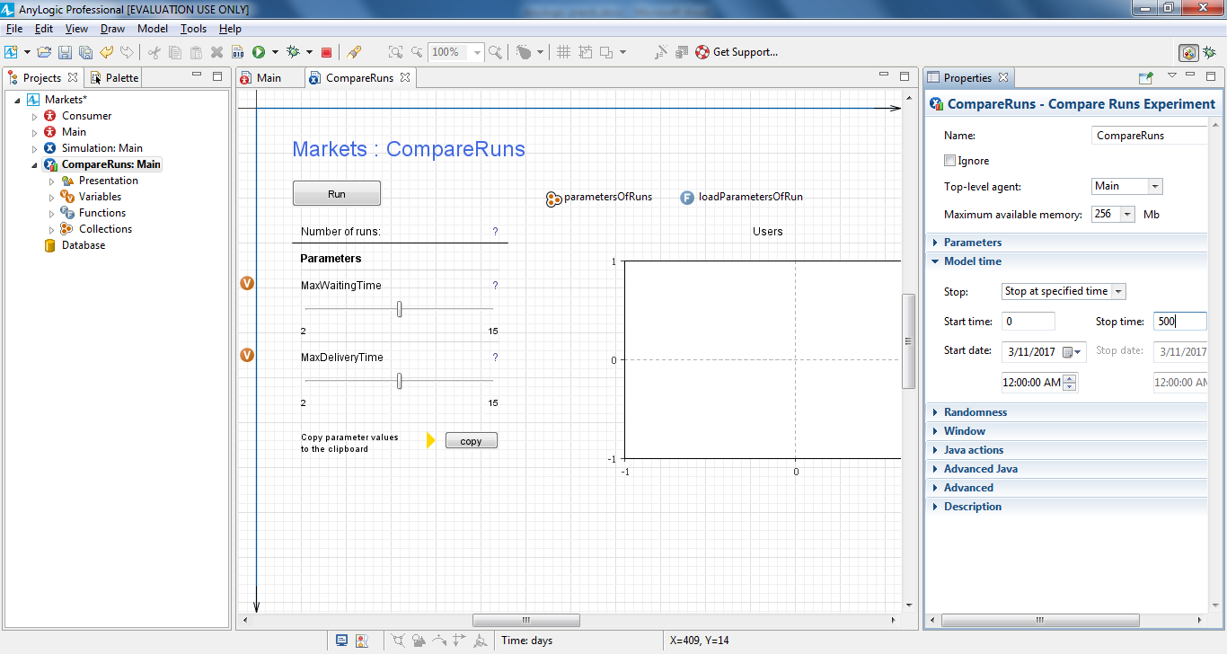

Run the experiment. Select the newly-created experiment from the **Run** list: **Market / CompareRuns**, or right-click the CompareRuns experiment in the **Projects** tree and select **Run** from the context menu.

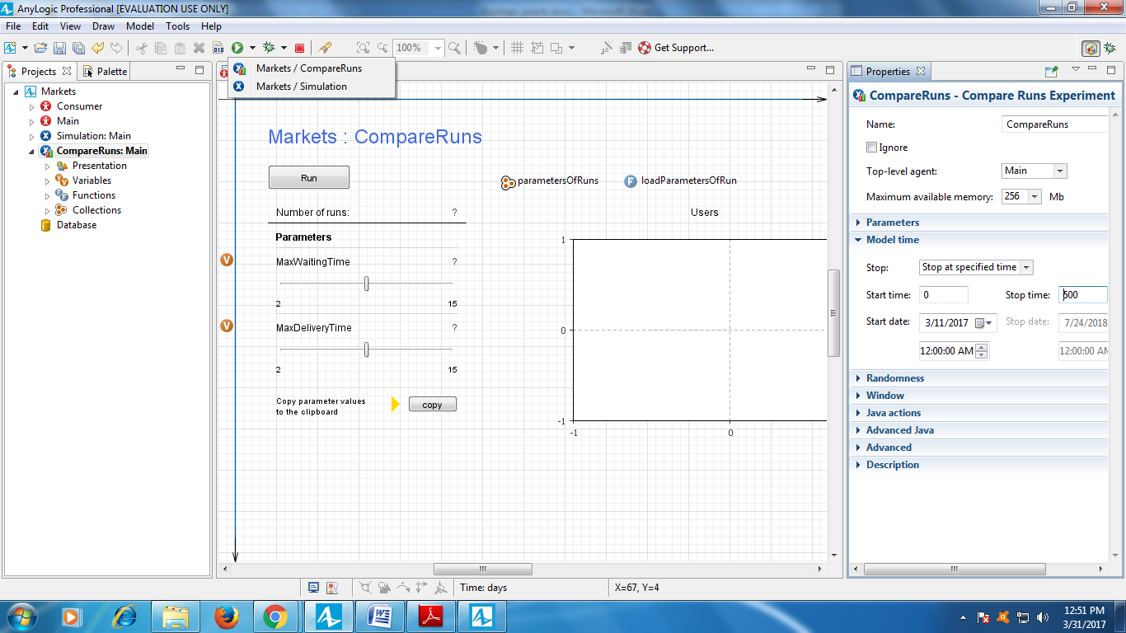

In the model window, click the **Run** button to see the result associated with the default parameter values. Afterward, change the parameter values and click **Run** again to observe the system behavior for the new settings. The chart displays all the results for your review.

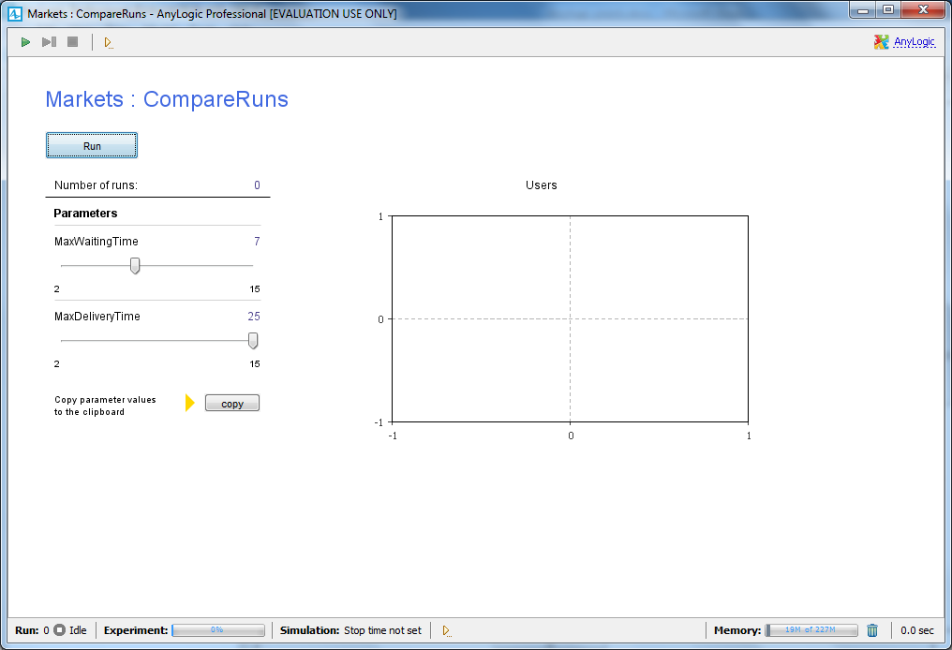

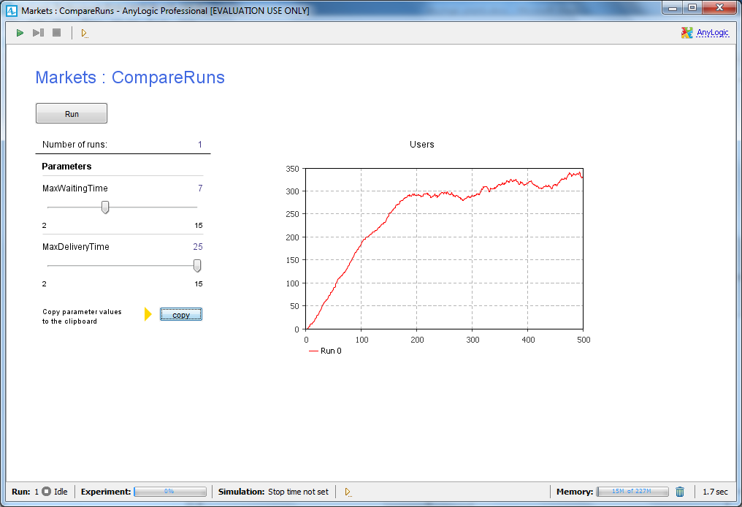

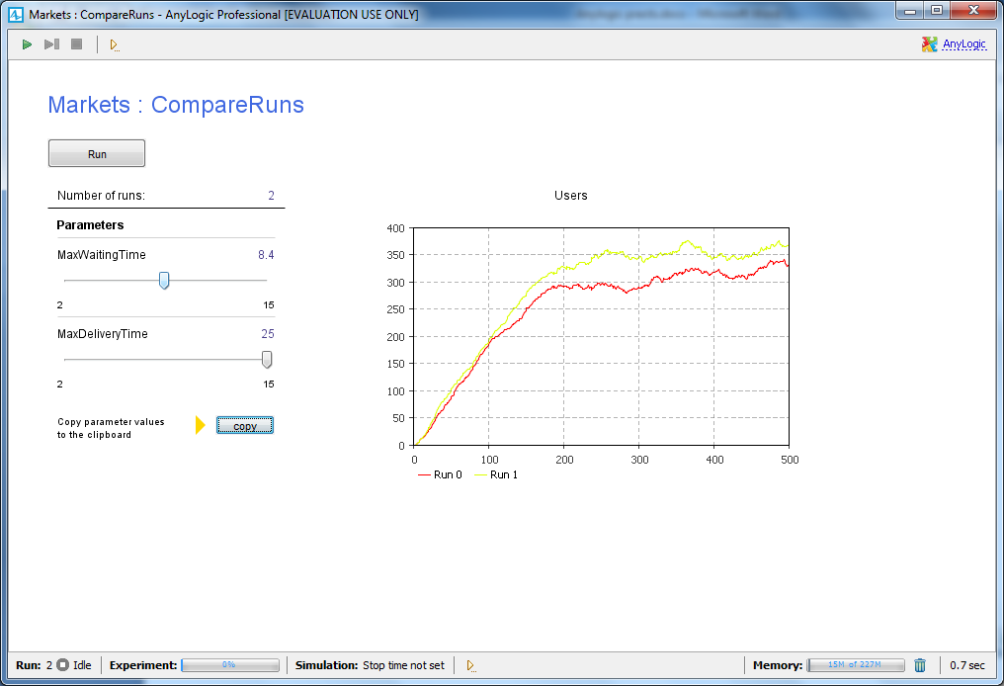

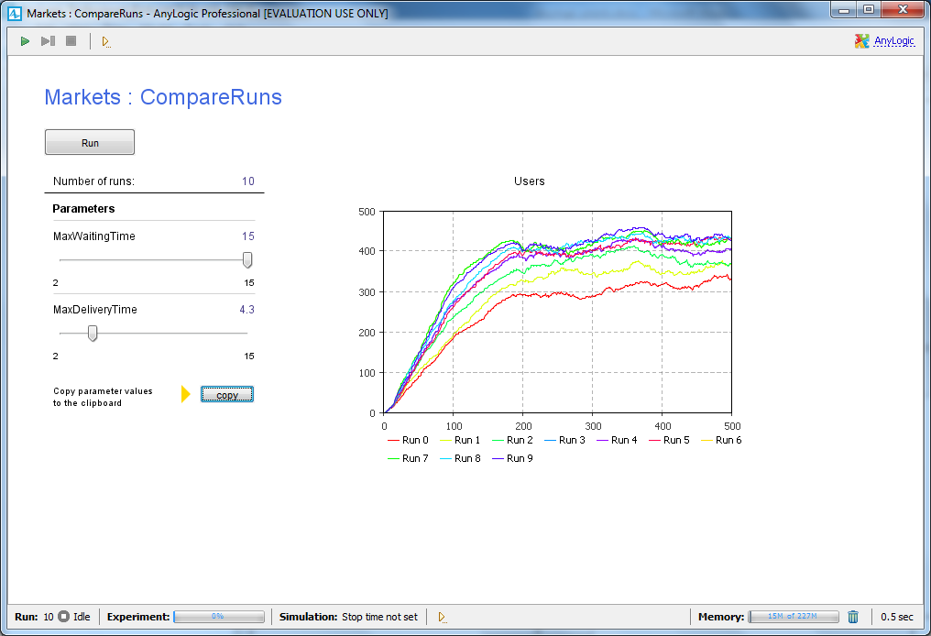

Each curve in a chart corresponds to a specific simulation run, and you can click any item in the chart’s legend to highlight the curves that correspond to the run. The controls on the left will show the values that led to this result. To deselect a curve, click on its legend a second time.

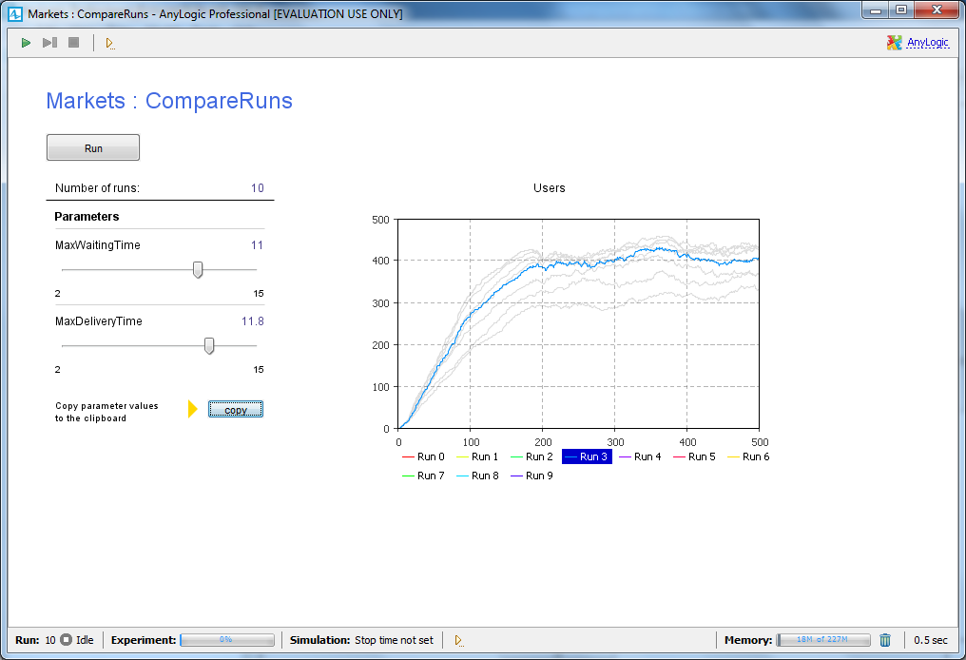

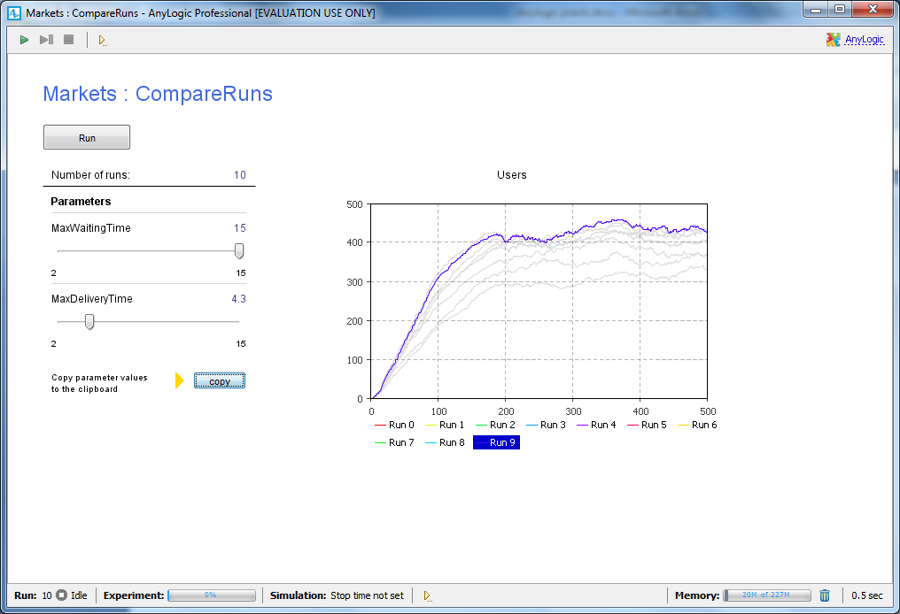

You can copy the datasets by clicking in the legend and selecting **Copy all** or **Copy selected** from the context menu.